
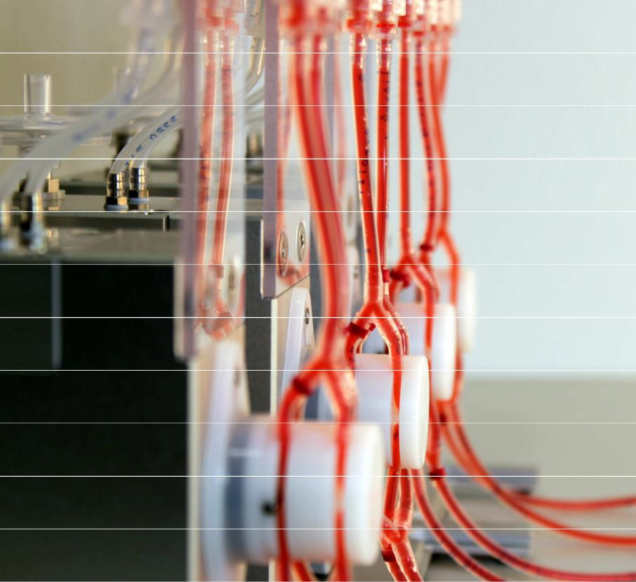
Instruction Manual for Oscillating
Flow
Version 1.5.0


ibidi instruction manual for oscillating flow
ii
© ibidi GmbH 2011, version 1.5.0, revision 1, 2012-08-03, Dr. Miro Kroutvar

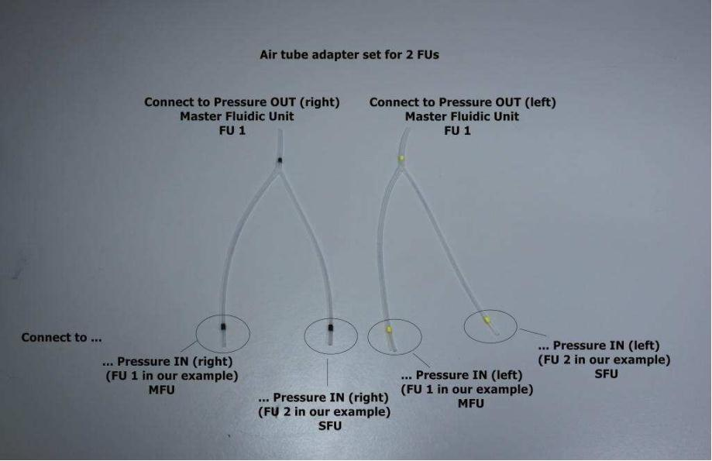
1 Instructions for oscillating flow experiments
In order to apply oscillating flow to the µ-Slides you need at least two Fluidic Units (one
‘master’ and one ‘slave’ Fluidic Unit) to separate the switching times of the two valves of
the Fluidic Unit as simultaneous switching results in unidirectional flow. The basic principle is
such that the master Fluidic Unit has a long switching time tmaster. During tmaster the master
Fluidic Unit supplies an unchanged air flow to the reservoirs of the slave Fluidic Unit. Now
the switching time of the slave Fluidic Unit tslave can be set as a fraction of the tmaster so that
the flow direction is reversed tmaster / tslave times before the master Fluidic Unit switches the
air flow to the reservoirs. As a result you have a setup were one Fluidic Unit creates a
unidirectional flow and one which supplies oscillating flow within the µ-Slide channel. Since
only one controlling master Fluidic Unit is needed but the pump can control up to four Fluidic
Units, you can extend the setup to operate with up to 3 oscillating slave Fluidic Units.
1.1 Setting up the Fluidic Units
You will also need air tubing splitters (Figure 1), besides the two Fluidic Units.
Figure 1: Air pressure splitter for 2 Fluidic Units
ibidi instruction manual for oscillating flow
© ibidi GmbH 2012, version 1.5.0, revision 1, 2012-08-03, Dr. Miro Kroutvar
1


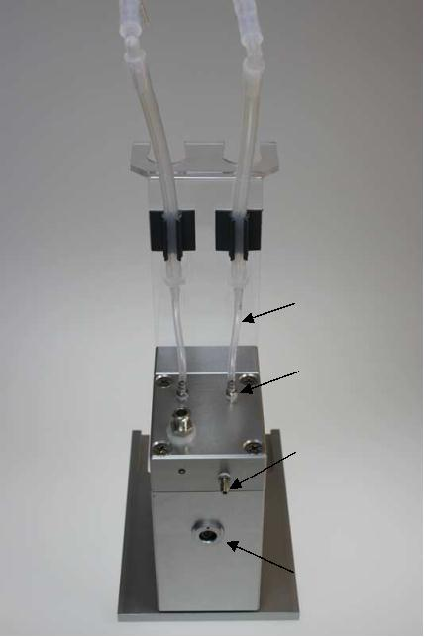
Pressure IN
Pressure
OUT
Pressured
air
connector
to pump
Valve
cable
connection
Figure 2: Fluidic Unit connectors
Please follow the steps below for correct installation and compare with Figure 2:
1) Connect the air pressure tube of the pump to the master Fluidic Unit.
2) Use one of the splitters, for example, the yellow marked to connect the left ‘Pressure
OUT’ port of the Master Fluidic Unit to
a) the left ‘Pressure IN’ port of the master Fluidic Unit and
b) the left ‘Pressure IN’ port of the slave Fluidic Unit.
3) Repeat step 2) with the black marked air splitters and the right side of the master and
slave Fluidic Unit.
4) Connect the pump and the two Fluidic Units with the electric cables. In the
presented case we use ‘Port 1’ for the master Fluidic Unit and ‘Port 2’ for the slave
Unit.
ibidi instruction manual for oscillating flow
2
© ibidi GmbH 2012, version 1.5.0, revision 1, 2012-08-03, Dr. Miro Kroutvar

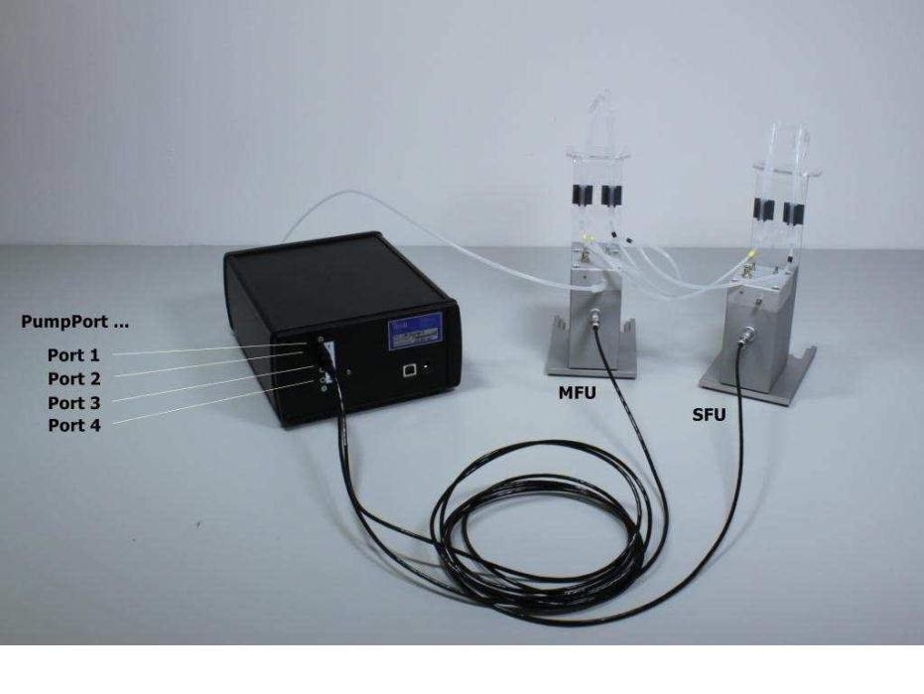
Figure 3: Connected master (MFU) and slave Fluidic Unit (SFU)
The setup should like like Figure 3
1.2 Oscillating experiment with 4 Fluidic Units
To extend an experiment to one master Unit and 3 oscillating slave Fluidic Units, a
corresponding air pressure splitter is needed. The connection is according to the setup with
two Fluidic Units. Figure 4 shows an example of the required air pressure tubing.
The connection is according to section 1.1 with a simple extension for the additional Fluidic
Units. The connection to the air pressure tubing is shown in Figure 5.
ibidi instruction manual for oscillating flow
© ibidi GmbH 2012, version 1.5.0, revision 1, 2012-08-03, Dr. Miro Kroutvar
3

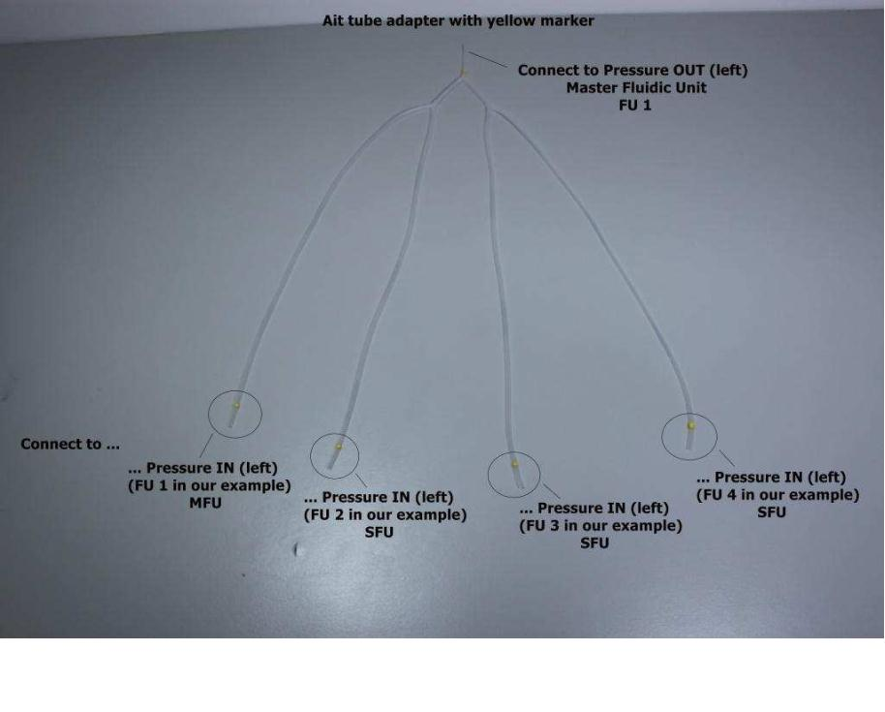
Figure 4: Air tubing for experiment with 4 Fluidic Units: 1 master Fluidic Unit (MFU) and 3 slave
Fluidic Units (SFU 1-3).
ibidi instruction manual for oscillating flow
4
© ibidi GmbH 2012, version 1.5.0, revision 1, 2012-08-03, Dr. Miro Kroutvar


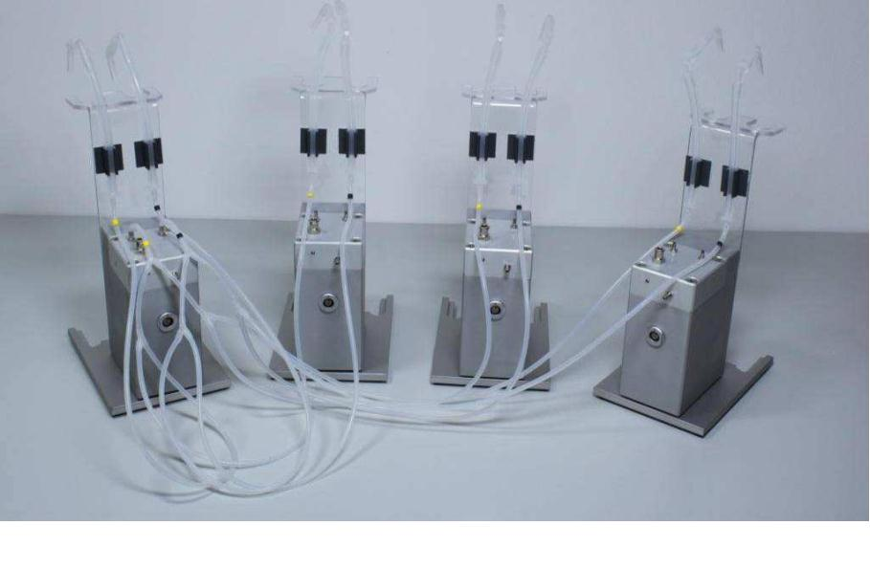
Figure 5: Air pressure connection with a setup using 4 Fluidic Units
1.3 Operation mode for oscillation flow experiments
Possible?
Oscillating flow
Continuous flow
Master Fluidic Unit (FU 1)
no
yes
yes
yes
yes
Slave Fluidic Unit
Slave Fluidic Unit
Slave Fluidic Unit
(FU 2)
(FU 3)
(FU 4)
yes
yes
yes
Please be aware that the master Fluidic Unit can only be used for unidirectional flow
experiments. All slave Fluidic Units can reverse the flow direction with switching times set
by PumpControl.
1.4 Settings within PumpControl
As the switching times are different for the master and the slave Fluidic Units the
PumpControl program of the ibidi Pump has to be set accordingly. For that you find in the
PumpControl software checkboxes for ‘continuous’ and ‘oscillating’ valves and switching
operations. Please check Figure 6 how to correctly set the corresponding parameters.
ibidi instruction manual for oscillating flow
© ibidi GmbH 2012, version 1.5.0, revision 1, 2012-08-03, Dr. Miro Kroutvar
5

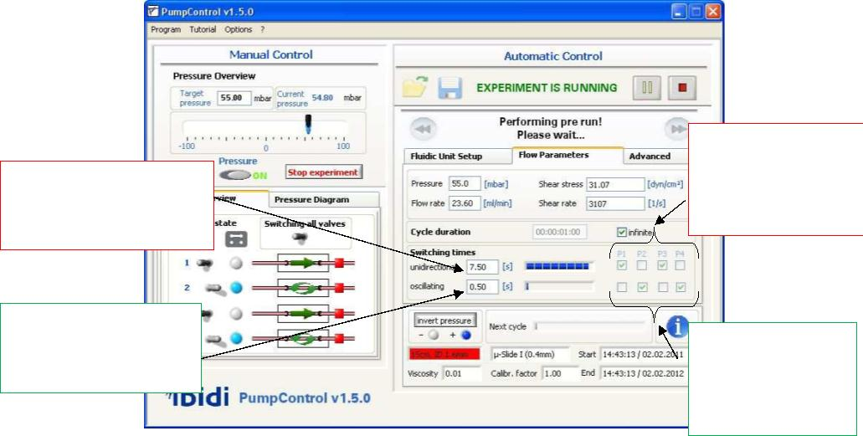
Pump port for
continuous flow:
master Fluidic
Unit
Slow switching time
for the master Fluidic
Unit: tmaster
Fast switching time
for the slave Fluidic
Unit: tslave
Pump ports for
oscillating flow:
Slave Fluidic
Units
Figure 6: Screen shot of settings for oscilalting experiments
1.5 Equilibrating master and slave Fluidic Units
As master and slave Fluidic Unit are connected to the same air pressure and switching time
equilibration of the liquid levels of both Fluidic Units cannot be done simultaneously. To stop
the liquid movement in the reservoirs of either Fluidic Unit the Perfusion Set has to be
clamped off (pinch off test described in instruction manual for the pump system) with the
supplied hose clamp. As the order is indifferent you can start off equilibrating the liquid
levels of the master Fluidic Unit by clamping off the Perfusion Set of the slave unit.
Afterwards the same should be done with the slave unit. This step is beneficial as it shows
if the Perfusion Set is mounted correctly in both Fluidic Units.
ibidi instruction manual for oscillating flow
6
© ibidi GmbH 2012, version 1.5.0, revision 1, 2012-08-03, Dr. Miro Kroutvar

ibidi instruction manual for oscillating flow
© ibidi GmbH 2012, version 1.5.0, revision 1, 2012-08-03, Dr. Miro Kroutvar
7

