
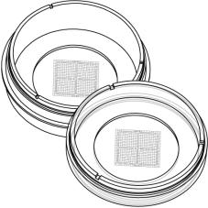

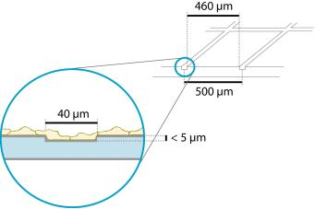
Instructions
µ–Dish 35mmGrid-500
Theibidiproductfamilyiscomprisedofavarietyofµ–Slidesandµ–Dishes,whichhave
allbeendesignedforhigh–endmicroscopicanalysisofﬁxedorlivingcells. Thehigh
opticalqualityofthematerialissimilartothatofglass,soyoucanperformallkindsof
ﬂuorescenceexperimentswithuncompromisedresolutionandchoiceofwavelength.
TheGrid–500isagridstructureforrelocatingevents. Itprovides400distinguishable
observationsquaresof500µmedgelength. Thegridisclearlyvisiblebyphasecontrast
microscopyandbasedonthehighqualityibidiStandardBottom.Theouterdimensions
areidenticaltoibidiµ–Dishes.
Material
Conditions
Shippingconditions
Storageconditions
Ambient
RT(15-25°C)
ibidiµ–Slides,µ–Dishes,andµ–Platesaremadeofaplas-
tic that has the highest optical quality. The bottom ma-
terial exhibits extremely low birefringence and autoﬂuo-
rescence, similar to that of glass. Also, it is not possible
todetachthebottomfromtheupperpart. Theµ–Slides,
µ–Dishes, and µ–Plates are not autoclavable, since they
areonlytemperature–stableupto80°C/175°F.Pleasenote
that gas exchange between the medium and incubator’s
atmosphere occurs partially through the polymer cover-
slip,whichshouldnotbecovered.
ShelfLifeofDifferentSurfaces
ibiTreat,GlassBottom,ESS
36months
18months
4months
Collagen,Poly-Lysine
Fibronectin
CharacteristicsoftheGrid
OpticalPropertiesibidiStandardBottom
The Grid–500 is made of small grooves inside the ibidi
plastic surface of ibidi µ–Dishes. The structure is im-
printedonthesideonwhichcellsaregrowinganddoes
noteffectcellgrowth,coatingprotocols,orsurfaceprop-
erties. Proliferationandcellbehavioriscomparablewith
standard non–gridded dishes. Cells and grid are in one
focalplane.
RefractiveindexnD(589nm)
Abbenumber
1.52
56
Thickness
No.1.5(180µm)
Material
microscopyplastic/
polymercoverslip
The grid is made of grooves, which are 40µm (±5µm)
wide and approximately 5µm deep. Cells can grow in
thegroovesaswell.Werecommendusingobjectivelenses
upto20×.Anyhow,theopticalqualitymeetstherequire-
mentsof63×and100×oilobjectivelensesaswell(ibidi
StandardBottom,No.1.5).
Please note! The ibidi Standard Bottom is compatible
withcertaintypesofimmersionoilonly. Alistofsuit-
ableoilscanbefoundonpage3.
ShippingandStorage
The µ–Slides, µ–Dishes and µ–Plates are sterilized and
weldedinagas-permeablepackaging.Theshelflifeunder
proper storage conditions (in a dry place, no direct sun-
light)islistedinthefollowingtable.
µ–Dish35mmGrid-500
Page1
Version2015-05-12

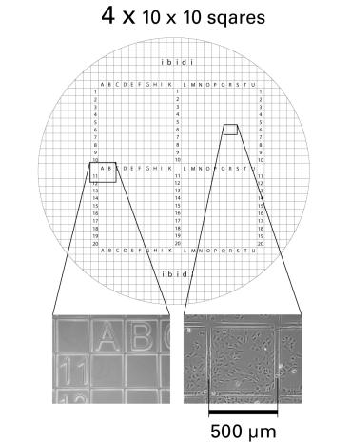
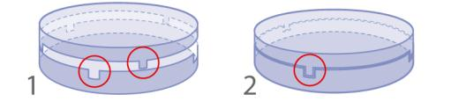
Instructions
µ–Dish 35mmGrid-500
GeometryoftheGrid–500
SurfaceandCoating
The µ–Dish 35mm Grid-500 is available with ibiTreat and
GeometryoftheGrid–500
uncoatedsurface. TheibiTreatsurfaceisaphysicaltreat-
mentandoptimizedforadhesionofmostcelltypes.Many
celllinesaswellasprimarycellsweretestedforgoodcell
growth. Theuncoatedsurfaceisaveryhydrophobicsur-
faceandallowsnodirectcellgrowth.Itissuitableforspe-
ciﬁccoatingsorsuspensioncells.
Numberofsquares
Repeatdistance
Groovewidth
400
500µm
40µm(±5µm)
< 5µm
Groovedepth
If you like to establish a particular coating for your de-
mandswerecommendtotestyourcoatingprocedureon
uncoatedandibiTreatµ–Dishes,sincesomebiomolecules
adhere differently to hydrophobic or hydrophilic plastic
surfaces.
Thefourmajorsquaresareseparatedin10×10observa-
tionﬁeldsandindicatedbylettersandnumbersranging
from:
• AtoK(Jnotused)and1to10
• AtoK(Jnotused)and11to20
• LtoUand1to10
• Prepareyourcoatingsolutionaccordingtotheman-
ufacturer’sspeciﬁcationsorreference. Prepareyour
µ–Dish,ibiTreatoruncoated. Adjusttheconcentra-
tiontoacoatingareaof4.2cm2and400µl.
• LtoUand11to20
• Apply400µlintothegrowtharea. Makesurethat
theentirebottomiscoveredwithliquideasilytilting
orshakingtheµ–Dish. Putonthelidandleaveat
roomtemperatureforatleast30minutes.
• Aspiratethesolutionandwash. Optionally,letdry
atroomtemperature.
DetailedinformationaboutcoatingsisprovidedinAppli-
cationNote08
Theµ–Dish 35mm,high isalsoavailablewithanelastically
supportedsurface(ESS)andaglassbottomsurface.Please
refertotheinstructionsfordetailedinformation.
SeedingCells
Depending on your cell type, application of a 4–9 ×
104cells/mlsuspensionshouldresultinaconﬂuentlayer
within2–3days.
• Trypsinizeandcountcellsasusual. Dilutethecell
suspensiontothedesiredconcentration.
• Apply400µlcellsuspensionintotheinnerwellof
theµ–Dish.Avoidshakingasthiswillresultininho-
mogeneousdistributionofthecells.
UsingTheLid
• Aftercellattachmentaddadditionally1.6ml(400µl
fortheµ–Dish35mmwithlowwalls)ofpuremedium
toensureoptimalgrowconditions.
• Covertheµ–Dishwiththesuppliedlid. Incubateat
37°Cand5%CO2asusual.
1. openposition,easyopening
Werecommendnottoﬁllmorethantheindicatedtotal
volumeintotheµ–Dish 35mmGrid-500inordertoavoid
theliquidcontactingthelid.
2. closeposition,forlongtermstudies,minimalevap-
oration
µ–Dish35mmGrid-500
Page2
Version2015-05-12


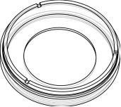
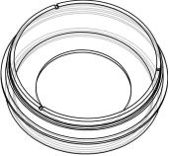
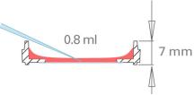
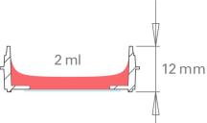
Instructions
µ–Dish 35mmGrid-500
Undemandingcellscanbeleftintheirseedingmediumfor
severaldaysandgrowtoconﬂuencethere.However,best
resultsareachievedwhenthemediumischangedevery
recommend sealing the lid with ibidi Anti–Evaporation
Oil(50051).
2–3days. Carefullyaspiratetheoldmediumandreplace
µ–Dish 35mmSelectionGuide
itbyupto2ml(800µlfortheµ–Dish35mmwithlowwalls)
freshmedium.
µ–Dish35mm,low
µ–Dish35mm,high
Low walls (7 mm) for large Highwalls(12mm)forallstan-
Tip:
access to the cells. Designed dardapplications.
for micromanipulation and mi- Also available with glass bot-
Youcanstacktheµ–Dishestosavespaceinyourincu-
bator.Thiswillnotaffectcellgrowth.Werecommend
making batches with up to 6 µ–Dishes, due to sta-
bilityreasons. Placingtheµ–DishesintolargerPetri
dishessimpliﬁestransportandpreventsevaporation,
heat loss, and contamination when the incubator is
opened.
croinjection.
tom,relocationgrid,andelastic
surface(ESS).
PreparationforCellMicroscopy
Toanalyzeyourcellsnospecialpreparationsarenecessary.
Cellscanbeobservedliveorﬁxeddirectlyintheµ–Dish
preferably on an inverted microscope. You can use any
ﬁxativeofyourchoice.Theµ–Dishmaterialiscompatible
withavarietyofchemicals,e.g.AcetoneorMethanol.Fur-
therspeciﬁcationscanbefoundatDueto
thethinbottomhighresolutionmicroscopyispossible.
For optimal results in ﬂuorescence microscopy and stor-
ageofstainedprobes,ibidiprovidesamountingmedium
optimized for µ–Dishes and µ–Slides (ibidi Mounting
Medium,50001).
ImmersionOil
When using oil immersion objectives, use only the im-
mersion oils speciﬁed in the table. The use of a non–
recommendedoilcouldleadtothedamageoftheplastic
materialandtheobjective.
MinimizingEvaporation
Usingtheµ–Dishwithaclosedlid,theevaporationinan
incubatorsystemwith37°Cand95%humidityisaround
1%perday. Usingtheµ–Dishwithaclosedlidina37°C
heating system with low humidity (between 20% and
40%),theevaporationisaround10%perday. Forreduc-
ingtheevaporationdownto1%perdayinallsystems,we
Company
Product
OrderingNumber
Zeiss
Zeiss
Leica
Immersol518F
ImmersolW2010
Immersionliquid
(Zeiss)444960
(Zeiss)444969
(Leica)11513859
SelectedReferences
H.-Y.Hsieh,T.-W.Huang,J.-L.Xiao,C.-S.Yang,C.-C.Chang,C.-C.Chu,L.-W.Lo,S.-H.Wang,P.-C.Wang,C.-C.Chieng,
C.-H.Lee,andF.-G.Tseng.Fabricationandmodiﬁcationofdual-facednano-mushroomsfortri-functionalcelltheranostics:
SERS/ﬂuorescencesignaling,proteintargeting,anddrugdelivery.JournalofMaterialsChemistry ,2012.
D.M.Seiler,J.Rouquette,V.J.Schmid,H.Strickfaden,C.Ottmann,G.A.Drexler,B.Mazurek,C.Greubel,V.Hable,and
G. Dollinger. Double-strand break-induced transcriptional silencing is associated with loss of tri-methylation at H3K4.
ChromosomeResearch,2011.doi:10.1007/s10577-011-9244-1.
µ–Dish35mmGrid-500
Page3
Version2015-05-12

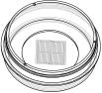
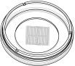
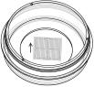
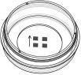
Instructions
µ–Dish 35mmGrid-500
S.Stoppelkamp,H.S.Bell,J.Palacios-Filardo,D.A.Shewan,G.Riedel,andB.Platt. InVitroModellingofAlzheimer’s
Disease: DegenerationandCellDeathInducedbyViralDeliveryofAmyloidandTau. ExperimentalNeurology,2011. doi:
10.1016/j.expneurol.2011.01.018.
P.Weinmeister,R.Lukowski,S.Linder,C.Traidl-Hoffmann,L.Hengst,F.Hofmann,andR.Feil. cGMP-dependentProtein
KinaseIPromotesAdhesionofPrimaryVascularSmoothMuscleCells. MolecularBiologyoftheCell,2008. doi: 10.1091/
mbc.E08-04-0370.
µ–Dish 35mmGridFamily
µ–Dish35mm,highGrid-500
Cat.No.
Description
Characteristics
81166
µ–Dish 35mm,high ibiTreat Grid-500: 35mm, high wall (2ml hydrophilic,sterilized
volume),#1.5polymercoverslip,tissueculturetreated,gridre-
peatdistance500µm
81161
µ–Dish 35mm,highUncoatedGrid-500: 35mm,highwall(2ml hydrophobic,sterilized
volume),#1.5polymercoverslip,gridrepeatdistance500µm
µ–Dish35mm,lowGrid-500
Cat.No.
Description
Characteristics
80156
µ–Dish 35mm,low ibiTreatGrid-500: 35mm,highwall(800µl hydrophilic,sterilized
volume),#1.5polymercoverslip,tissueculturetreated,gridre-
peatdistance500µm
80151
µ–Dish35mm,lowUncoatedGrid-500:35mm,highwall(800µl hydrophobic,sterilized
volume),#1.5polymercoverslip,gridrepeatdistance500µm
µ–Dish35mm,highGlassBottomGrid–500
Cat.No.
Description
Characteristics
81168
µ–Dish 35mm,high GlassBottomGrid–500: 35mm,highwall
sterilized
(2mlvolume),#1.5H(170±5µm)D263MSchottglass,gridre-
peatdistance500µm
µ–Dish35mm,highGlassBottomGrid–50
Cat.No.
Description
Characteristics
81148
µ–Dish 35mm,high Glass Bottom Grid–50: 35mm, high wall
sterilized
(2mlvolume),#1.5H(170±5µm)D263MSchottglass,gridre-
peatdistance50µm
Forresearchuseonly!
FurthertechnicalspeciﬁcationscanbefoundatForquestionsandsuggestionspleasecontactusbye-mailinfo@ibidi.de
orbytelephone+49(0)89/52046170.AllproductsaredevelopedandproducedinGermany.
©ibidiGmbH,AmKlopferspitz19,82152Martinsried,Germany.
µ–Dish35mmGrid-500
Page4
Version2015-05-12

