
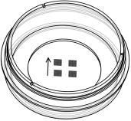

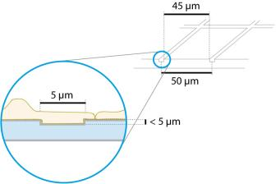
Instructions
µ–Dish 35mm,highGlassBottomGrid–50
Theibidiproductfamilyiscomprisedofavarietyofµ–Slidesandµ–Dishes,whichhaveallbeen
designedforhigh–endmicroscopicanalysisofﬁxedorlivingcells.
Theglassbottomversionsoftheµ–Slidesandµ–DishesareespeciallydesignedforTIRFandsingle
moleculeapplications. Theµ–Dish35mm,highGlassBottomGrid–50allowsyoutoperformhighres-
olutionmicroscopyina35mmPetri–dishwith12mmwalls.Thestandardheightallowsconvenient
liquidhandling.Thelidcanbeclosedtohinderevaporationduringlongtermexperiments.
TheGrid–50isagridstructureforrelocatingeventsonaglasscoverslip. Itprovides4×400distinguishableobservation
squaresof50µmedgelength. Thegridisclearlyvisiblebyphasecontrastmicroscopyandimprintedintoamicroscopy
coverslip.Theouterdimensionsandotherparametersareidenticaltoibidiµ–Dishes.
Material
Conditions
Shippingconditions
Storageconditions
Ambient
Theµ–Dish 35mm,high GlassBottomGrid–50ismadeofa
standardµ–Dish35mm,high butwithaglasscoverslipbot-
RT(15-25°C)
tom.Itisnotpossibletodetachthebottom.Theµ–Dishes
arenotautoclavablesincetheyaretemperaturestableonly
upto80°C/175°F.
ShelfLifeofDifferentSurfaces
ibiTreat,GlassBottom,ESS
36months
18months
4months
Collagen,Poly-Lysine
Fibronectin
OpticalPropertiesibidiGlassBottom
RefractiveindexnD
Abbenumber
Thickness
1.523
55
CharacteristicsoftheGrid
No.1.5H(selectedquality
170µm,±5µm)
TheGrid–50ismadeofsmallgroovesthatareimprinted
intoamicroscopycoverglass. Thestructureisimprinted
on the side on which cells are growing. Cells and grid
areinonefocalplane. Thereisnoreportedeffectoncell
growth,coatingprotocols,orsurfaceproperties. Prolifer-
ation and cell behavior is comparable to standard non–
griddedglasscoverslips. Washingsteps(e.g. withPBS)
beforecellseedingcanremoveglassdustwhichisadvan-
tageousfordirectcellgrowthonthesurface.
Material
Schottborosilicateglass,
D263M
Attention!
Be cautious when handling µ–Slides and µ–Dishes
with glass bottom! The glass coverslip is very frag-
ileandmightbreakeasily. Handlewithcaretoavoid
physicalinjuryanddamagetodevicesthroughleak-
ageofthemedium.
Pleasealsorefertotheinstructionsofibidiµ–Dishesglass
bottom for information on surfaces, coatings, and cell
seeding.
Thegroovesare5 µm(±1µm)wideandapproximately5
µmdeep. Cellscangrowinthegroovesaswell. Werec-
ommendusingobjectivelenses20×orhigher.
ShippingandStorage
The µ–Slides, µ–Dishes and µ–Plates are sterilized and
weldedinagas-permeablepackaging.Theshelflifeunder
proper storage conditions (in a dry place, no direct sun-
light)islistedinthefollowingtable.
µ–Dish35mm,highGlassBottomGrid–50
Page1
Version2015-05-12

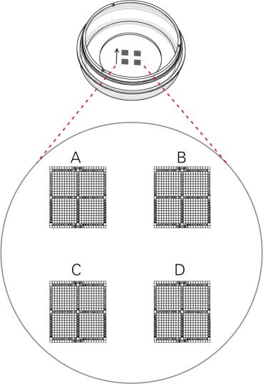
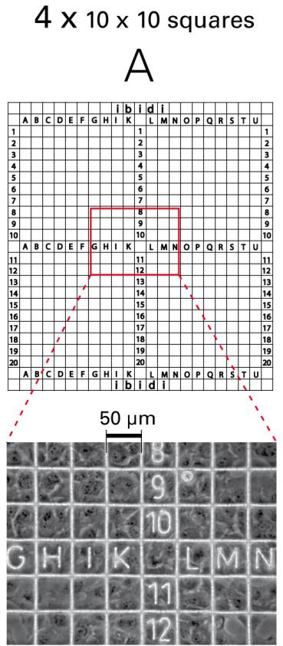
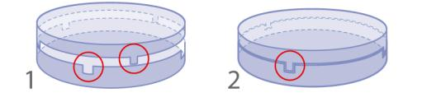
Instructions
µ–Dish 35mm,highGlassBottomGrid–50
GeometryoftheGrid–50
GeometryoftheGrid–50
Numberofsquares
Repeatdistance
Groovewidth
4x400
50µm
5µm(±1µm)
< 5µm
Groovedepth
TherearefourgridsnumberedfromAtoD.Eachconsists
offourmajorsquareswhichareseparatedin10×10obser-
vationﬁeldsandindicatedbylettersandnumbersranging
from:
• AtoK(Jnotused)and1to10
• AtoK(Jnotused)and11to20
• LtoUand1to10
• LtoUand11to20
Microscopic image of the grid with rat ﬁbroblast
cells(20×objectivelensphasecontrast).
UsingTheLid
TherearefourgridsnumberedfromAtoD.
1. openposition,easyopening
2. closeposition,forlongtermstudies,minimalevap-
oration
µ–Dish35mm,highGlassBottomGrid–50
Page2
Version2015-05-12


Instructions
µ–Dish 35mm,highGlassBottomGrid–50
SurfaceandCoating
Tip:
The µ–Dish 35mm,high Glass Bottom Grid–50 is manufac-
tured with an uncoated glass coverslip. Washing steps
(e.g. withPBS)beforecellseedingcanremoveglassdust
whichisadvantageousfordirectcellgrowthonthesur-
face.
Youcanstacktheµ–Dishestosavespaceinyourincu-
bator.Thiswillnotaffectcellgrowth.Werecommend
making batches with up to 6 µ–Dishes, due to sta-
bilityreasons. Placingtheµ–DishesintolargerPetri
dishessimpliﬁestransportandpreventsevaporation,
heat loss, and contamination when the incubator is
opened.
Protein coatings increase direct cell growth of adherent
cells.Speciﬁccoatingsonglassarepossiblefollowingthis
protocol:
• Prepareyourcoatingsolutionaccordingtotheman-
ufacturer’sspeciﬁcationsorreference. Prepareyour
µ–Dish.Adjusttheconcentrationtoacoatingareaof
4.2cm2and400µl.
PreparationforCellMicroscopy
Toanalyzeyourcellsnospecialpreparationsarenecessary.
Cellscanbeobservedliveorﬁxeddirectlyintheµ–Dish
preferably on an inverted microscope. You can use any
ﬁxativeofyourchoice.Theµ–Dishmaterialiscompatible
withavarietyofchemicals,e.g.AcetoneorMethanol.Fur-
therspeciﬁcationscanbefoundatDueto
thethinbottomhighresolutionmicroscopyispossible.
• Apply400µlintothegrowtharea. Makesurethat
theentirebottomiscoveredwithliquideasilytilting
orshakingtheµ–Dish. Putonthelidandleaveat
roomtemperatureforatleast30minutes.
• Aspiratethesolutionandwash. Optionally,letdry
atroomtemperature.
For optimal results in ﬂuorescence microscopy and stor-
ageofstainedprobes,ibidiprovidesamountingmedium
optimized for µ–Dishes and µ–Slides (ibidi Mounting
Medium,50001).
DetailedinformationaboutcoatingsisprovidedinAppli-
cationNote08
SeedingCells
MinimizingEvaporation
Depending on your cell type, application of a 4–9 ×
104cells/mlsuspensionshouldresultinaconﬂuentlayer
within2–3days.
Usingtheµ–Dishwithaclosedlid,theevaporationinan
incubatorsystemwith37°Cand95%humidityisaround
1%perday. Usingtheµ–Dishwithaclosedlidina37°C
heating system with low humidity (between 20% and
40%),theevaporationisaround10%perday. Forreduc-
ingtheevaporationdownto1%perdayinallsystems,we
recommend sealing the lid with ibidi Anti–Evaporation
Oil(50051).
• Trypsinizeandcountcellsasusual. Dilutethecell
suspensiontothedesiredconcentration.
• Apply400µlcellsuspensionintotheinnerwellof
theµ–Dish.Avoidshakingasthiswillresultininho-
mogeneousdistributionofthecells.
• Aftercellattachmentaddadditionally1.6mlofpure
mediumtoensureoptimalgrowconditions.
ImmersionOil
• Covertheµ–Dishwiththesuppliedlid. Incubateat
37°Cand5%CO2asusual.
When using oil immersion objectives, use only the im-
mersion oils speciﬁed in the table. The use of a non–
recommendedoilcouldleadtothedamageoftheplastic
materialandtheobjective.
Werecommendnottoﬁllmorethantheindicatedtotal
volumeintotheµ–Dish 35mm,highGlassBottomGrid–50
inordertoavoidtheliquidcontactingthelid.
Company
Product
OrderingNumber
Undemandingcellscanbeleftintheirseedingmediumfor
severaldaysandgrowtoconﬂuencethere.However,best
resultsareachievedwhenthemediumischangedevery
2–3days. Carefullyaspiratetheoldmediumandreplace
itbyupto2mlfreshmedium.
Zeiss
Zeiss
Leica
Immersol518F
ImmersolW2010
Immersionliquid
(Zeiss)444960
(Zeiss)444969
(Leica)11513859
µ–Dish35mm,highGlassBottomGrid–50
Page3
Version2015-05-12

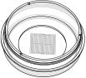
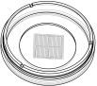
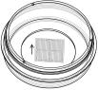
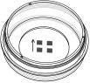
Instructions
µ–Dish 35mm,highGlassBottomGrid–50
µ–Dish 35mmGridFamily
µ–Dish35mm,highGrid-500
Cat.No.
Description
Characteristics
81166
µ–Dish 35mm,high ibiTreat Grid-500: 35mm, high wall (2ml hydrophilic,sterilized
volume),#1.5polymercoverslip,tissueculturetreated,gridre-
peatdistance500µm
81161
µ–Dish 35mm,highUncoatedGrid-500: 35mm,highwall(2ml hydrophobic,sterilized
volume),#1.5polymercoverslip,gridrepeatdistance500µm
µ–Dish35mm,lowGrid-500
Cat.No.
Description
Characteristics
80156
µ–Dish 35mm,low ibiTreatGrid-500: 35mm,highwall(800µl hydrophilic,sterilized
volume),#1.5polymercoverslip,tissueculturetreated,gridre-
peatdistance500µm
80151
µ–Dish35mm,lowUncoatedGrid-500:35mm,highwall(800µl hydrophobic,sterilized
volume),#1.5polymercoverslip,gridrepeatdistance500µm
µ–Dish35mm,highGlassBottomGrid–500
Cat.No.
Description
Characteristics
81168
µ–Dish 35mm,high GlassBottomGrid–500: 35mm,highwall
sterilized
(2mlvolume),#1.5H(170±5µm)D263MSchottglass,gridre-
peatdistance500µm
µ–Dish35mm,highGlassBottomGrid–50
Cat.No.
Description
Characteristics
81148
µ–Dish 35mm,high Glass Bottom Grid–50: 35mm, high wall
sterilized
(2mlvolume),#1.5H(170±5µm)D263MSchottglass,gridre-
peatdistance50µm
Forresearchuseonly!
FurthertechnicalspeciﬁcationscanbefoundatForquestionsandsuggestionspleasecontactusbye-mailinfo@ibidi.de
orbytelephone+49(0)89/52046170.AllproductsaredevelopedandproducedinGermany.
©ibidiGmbH,AmKlopferspitz19,82152Martinsried,Germany.
µ–Dish35mm,highGlassBottomGrid–50
Page4
Version2015-05-12

