
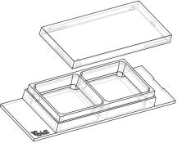

Instructions
µ–Slide2Well Ph+GlassBottom
Theibidiproductfamilyiscomprisedofavarietyofµ–Slidesandµ–Dishes,whichhave
allbeendesignedforhigh–endmicroscopicanalysisofﬁxedorlivingcells.
Theglassbottomversionsoftheµ–Slidesandµ–DishesareespeciallydesignedforTIRF
andsinglemoleculeapplications.
Theµ–Slide2Well Ph+GlassBottom(Phasecontrastplus)isanarrayof2squareﬁelds
wherecellscanbecultivatedandinvestigatedwithmicroscopicalmethods. Theµ–Slide
2WellPh+GlassBottomimprovestheopticalqualityofphasecontrastmicroscopy.Incon-
trasttotheclassicµ–Slide2Well,thePh+versionprovidesaspecialplateinthecenterof
thewells.Thisplatesuppressesthemeniscuswhichisdisturbingthephasecontrasteffectinnormalopenwells.Openings
nearthecornersprovideaccesstothewellsforﬁllingandaspiratingliquidseasily.
Material
ShelfLifeofDifferentSurfaces
ibiTreat,GlassBottom,ESS
Collagen,Poly-Lysine
Fibronectin
36months
18months
4months
The glass bottom version of the µ–Slides are made of a
standardµ–Slidebutwithaglasscoverslipbottom. Itis
not possible to detach the bottom. The µ–Slides are not
autoclavablesincetheyaretemperaturestableonlyupto
80°C/175°F.
Geometry
OpticalPropertiesibidiGlassBottom
Theµ–Slide2Well Ph+GlassBottomprovidesastandard
slideformataccordingtoISO8037/1.
RefractiveindexnD
Abbenumber
Thickness
1.523
55
No.1.5H(selectedquality
170µm,±5µm)
Geometryofµ–Slide2WellPh+GlassBottom
Numberofwells
2
Material
Schottborosilicateglass,
D263M
Dimensionsofwells(w×l×h)inmm 21.2 × 23.3 ×
3.0
Growthareaperwell
Coatingareaperwell
Volumeperwell
4.8cm2
11.4cm2
Attention!
1.5ml
Be cautious when handling µ–Slides and µ–Dishes
with glass bottom! The glass coverslip is very frag-
ileandmightbreakeasily. Handlewithcaretoavoid
physicalinjuryanddamagetodevicesthroughleak-
ageofthemedium.
Liquidheight
3.0mm
10.8mm
No.1.5
Totalheightwithlid
Bottommatchescoverslip
Surfaceandcoating
Theµ–Slide2WellPh+GlassBottomismanufacturedwith
ShippingandStorage
anuncoatedglasscoverslip.Washingsteps(e.g.withPBS)
beforecellseedingcanremoveglassdustwhichisadvan-
tageousfordirectcellgrowthonthesurface.
The µ–Slides, µ–Dishes and µ–Plates are sterilized and
weldedinagas-permeablepackaging.Theshelflifeunder
proper storage conditions (in a dry place, no direct sun-
light)islistedinthefollowingtable.
Protein coatings increase direct cell growth of adherent
cells.Speciﬁccoatingsonglassarepossiblefollowingthis
protocol:
Conditions
• Prepareyourcoatingsolutionaccordingtotheman-
ufacturer’sspeciﬁcationsorreference. Prepareyour
µ–Slide.Adjusttheconcentrationtoacoatingareaof
11.4cm2and1.5ml.
Shippingconditions
Storageconditions
Ambient
RT(15-25°C)
µ–Slide2WellPh+GlassBottom
Page1
Version2.0(2015-11-22)


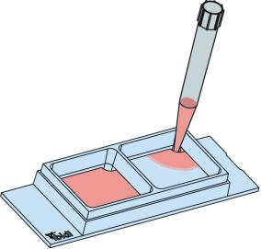
Instructions
µ–Slide2Well Ph+GlassBottom
• Apply1.5mlintothegrowtharea. Makesurethat
theentirebottomiscoveredwithliquideasilytilting
orshakingtheµ–Slide. Putonthelidandleaveat
roomtemperatureforatleast30minutes.
FillingandHandling
• Aspirate the solution and wash with the recom-
mendedproteindilutionbuffer. Optionally, letdry
atroomtemperature. Attention, somecoatingpro-
teinsmightdegeneratewhendrying!
Fill the wells by using a standard pipet. Inject the cell
suspensiondirectlyintooneoftheopenings.Mediumex-
changeiseasilydonebyaspiratingtheentirevolumeand
reﬁllingusing1.5mlperwell.
SolventsforFixationandStaining
Cellscanbeobservedliveorﬁxeddirectlyintheµ–Slide
preferablyonaninvertedmicroscope.Theslidematerialis
compatibletoacids,alkalis,PFA,andsiliconeoil.Alcohols
maybeusedforshorttermincubation(e.g. cellﬁxation).
Acetoneisnotcompatible. Furtherspeciﬁcationscanbe
foundat
For optimal results in ﬂuorescence microscopy and stor-
ageofstainedprobesibidiprovidesamountingmedium
(50001)optimizedforµ–Dishesandµ–Slides.
SeedingCells
• Trypsinizeandcountcellsasusual. Dilutethecell
suspensiontothedesiredconcentration.Depending
onyourcelltype,applicationofa5-11×104cells/ml
suspensionshouldresultinaconﬂuentlayerwithin
2–3days.
• Apply1.5mlcellsuspensionintoeachwelloftheµ–
Slide.Avoidshakingasthiswillresultininhomoge-
neousdistributionofthecells.
ImmersionOil
• Cover the slide with the supplied lid. Incubate at
37°Cand5%CO2asusual.
Undemanding cells can be left in their seeding medium
foruptothreedaysandgrowtoconﬂuencethere. How-
ever, best results might be achieved when the medium
is changed every 1–2 days. Carefully aspirate the old
medium and replace it by 1.5ml/well fresh medium.
When using oil immersion objectives, use only the im-
mersion oils speciﬁed in the table. The use of a non–
recommendedoilcouldleadtothedamageoftheplastic
materialandtheobjective.
Tip:
Thedaybeforeseedingthecellswerecommendplac-
ingthecellmediumandtheµ–Slideintotheincubator
forequilibration. Thiswillpreventtheliquidinside
fromemergingairbubblesovertheincubationtime.
Company
Product
OrderingNumber
Zeiss
Zeiss
Leica
Immersol518F
ImmersolW2010
Immersionliquid
(Zeiss)444960
(Zeiss)444969
(Leica)11513859
µ–Slide2WellPh+GlassBottom
Page2
Version2.0(2015-11-22)

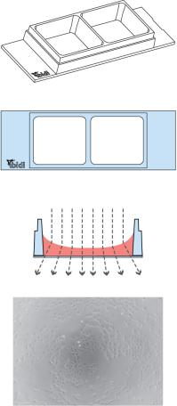
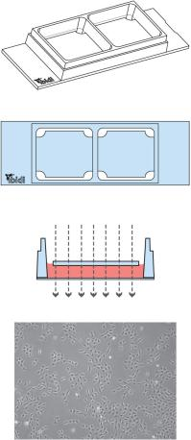
Instructions
µ–Slide2Well Ph+GlassBottom
µ–Slide2well Ph+selectionguide
µ–Slide2Well
µ–Slide2WellPh+
Standard open wells for maxi- Specialplateinthecenterofthe
mum sample access.
Meniscus
wells suppresses meniscus for-
mation. Nomeniscus–parallel
disturbs the beam path.
Good
phasecontrastqualityonlyinthe beampath. Forexcellentphase
centerofeachwell
contrastmicroscopyalloverthe
wells.
µ–Slide2WellPh+GlassBottom
Page3
Version2.0(2015-11-22)

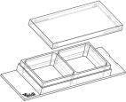
Instructions
µ–Slide2Well Ph+GlassBottom
OrderingInformation
Theµ–Slide2WellisavailableasopenwellandasaPh+version,aswellasinaglassbottomversion. Seetablebelowfor
choosingyourµ–Slide2Well.
µ–Slide2Well
Cat.No.
Description
80886
80882
80883
80884
80885
80881
80887
µ–Slide2WellibiTreat:#1.5polymercoverslip,tissueculturetreated,sterilized
µ–Slide2WellCollagenIV:#1.5polymercoverslip,sterilized
µ–Slide2WellFibronectin:#1.5polymercoverslip,sterilized∗
µ–Slide2WellPoly-L-Lysine:#1.5polymercoverslip,sterilized
µ–Slide2WellPoly-D-Lysine:#1.5polymercoverslip,sterilized∗
µ–Slide2WellUncoated:#1.5polymercoverslip,hydrophobic,sterilized
µ–Slide2WellGlassBottom:1.5H(170µm±5µm)D263MSchottglass,sterilized
∗availableonrequestonly
µ–Slide2WellPh+
Cat.No.
Description
80296
80292
80293
80294
80295
80291
80297
µ–Slide2WellPh+ibiTreat:#1.5polymercoverslip,tissueculturetreated,sterilized
µ–Slide2WellPh+CollagenIV:#1.5polymercoverslip,sterilized
µ–Slide2WellPh+Fibronectin:#1.5polymercoverslip,sterilized∗
µ–Slide2WellPh+Poly-L-Lysine:#1.5polymercoverslip,sterilized
µ–Slide2WellPh+Poly-D-Lysine:#1.5polymercoverslip,sterilized∗
µ–Slide2WellPh+Uncoated:#1.5polymercoverslip,hydrophobic,sterilized
µ–Slide2WellPh+GlassBottom:1.5H(170µm±5µm)D263MSchottglass,sterilized
∗availableonrequestonly
Forresearchuseonly!
FurthertechnicalspeciﬁcationscanbefoundatForquestionsandsuggestionspleasecontactusbye-mailinfo@ibidi.de
orbytelephone+49(0)89/52046170.AllproductsaredevelopedandproducedinGermany.
©ibidiGmbH,AmKlopferspitz19,82152Martinsried,Germany.
µ–Slide2WellPh+GlassBottom
Page4
Version2.0(2015-11-22)

