


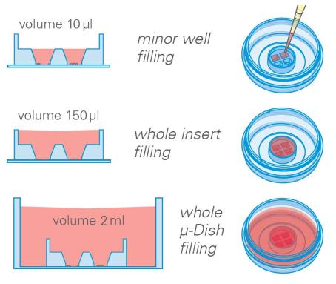

Instructions
micro–Insert4Well
Themicro–Insert4Wellisaproductforlongtermmicroscopystudiesespeciallystemcellcultivation.
Aspecialstickyandbiocompatiblesurfaceatthebottomsideworkslikeaglueandavoidsleaking.
Adherent or non–adherent cells placed into the small wells sink to the bottom and can be analyzed
microscopically. Thewellsproviderectangulardigitalformat(4:3)forcoveringtheentireareabyCCD
cameras on microscopes. Inclined walls provide excellent optical access to all cells located near the
edgesofthewell.Optionally,aftercellattachmenttheinsertcanberemovedbyusingsteriletweezers.
Therearenoremainsonthesurface.
Material
SeedingCells
• Preparecellsuspensionasusual.Dependingonyour
Themicro–Insert4Wellismanufacturedfrombiocompat-
ible silicone material. Although, the material is auto-
clavableandcompatibletoalcoholswedonotrecommend
reusingit.
celltypeapplicationofa1-7×105cells/mlshould
resultinaconﬂuentlayerwithin24hours.
• Apply 10 µl into each well. Avoid shaking as this
willresultininhomogeneouscelldistribution.
Pleasenote! Whenusingaibidiµ–Dish,µ–Slideorµ–
Platetakecarethattheibidistandardbottomiscompat-
iblewithcertaintypesofimmersionoilonly. Alistof
suitableoilscanbefoundonpage2.
• Incubateat37°Cand5%CO2asusual.
• Optionally,itispossibletoﬁlltheouterareawithcell
suspensionorcellmedium.
• Conductyourexperiment.
Geometry
Geometryofthemicro–Insert4Well
Numberofwells
Welldimensions
Growthareaperwell
Coatingareaperwell
Diameter
4
2.0mm×1.5mm
0.03cm2
0.23cm2
12mm
4.2mm
10µl
Height
Volumesmallwell
Volumecompleteinsert
150µl
Werecommendusingthemicro–Insert4Wellinibidiµ–
Dishes,µ–Slide2Well,6wellplates,12wellplatesorlarge
Petridishes. Itisalsopossibletousethemonsterileglass
coverslipsorglassslides.
Tip:
In case the cell lawn is (partially) removed together
withtheinsertuseasmallerseedingdensitytocreate
alessconﬂuentcelllayerordecreaseincubationtime.
SurfacesandCoatings
Theinsertscanbetransferredtoanyﬂat, clean, anddry
surface. Usesteriletweezersfortransferandgentlypush.
Keepinmindthatonlythebottomsideissticky. micro–
Insert4Wellisnotworkingonwetormoistsurfaces. It
mightalsonotworkonunevenordustysubstrates.
micro–Insert4Well
Page1
Version2013-01-10

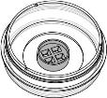
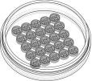
Instructions
micro–Insert4Well
ShippingandStorage
ImmersionOil
The µ–Slides, µ–Dishes and µ–Plates are sterilized and
weldedinagas-permeablepackaging.Theshelflifeunder
proper storage conditions (in a dry place, no direct sun-
light)islistedinthefollowingtable.
When using oil immersion objectives, use only the im-
mersion oils speciﬁed in the table. The use of a non–
recommendedoilcouldleadtothedamageoftheplastic
materialandtheobjective.
Conditions
Company
Product
OrderingNumber
Shippingconditions
Storageconditions
Ambient
ibidi
Zeiss
Zeiss
Leica
ImmersionOil
(ibidi)50101
RT(15-25°C)
Immersol518F
ImmersolW2010
Immersionliquid
(Zeiss)444960
(Zeiss)444969
(Leica)11513859
ShelfLifeofDifferentSurfaces
ibiTreat,glassbottom,ESS
36months
18months
4months
Collagen,Poly-Lysine
Fibronectin
micro–Insert4WellFamily
Themicro–Insert4Wellisavailableindifferentproductversions.
micro–Insert4Wellinµ–Dish35mm,high
Cat.No.
Description
Characteristics
80406
micro–Insert4Wellinµ–Dish35mm,highibiTreat:readytouse sterilized,hydrophilic
25micro–Inserts4Wellforselfinsertion
Cat.No.
Description
Characteristics
80409
25micro–Inserts4Wellforselfinsertion:ina10cmtransport
dish
sterilized
Forresearchuseonly!
FurthertechnicalspeciﬁcationscanbefoundatForquestionsandsuggestionspleasecontactusbye-mailinfo@ibidi.de
orbytelephone+49(0)89/52046170.AllproductsaredevelopedandproducedinGermany.
©ibidiGmbH,AmKlopferspitz19,82152Martinsried,Germany.
micro–Insert4Well
Page2
Version2013-01-10

