
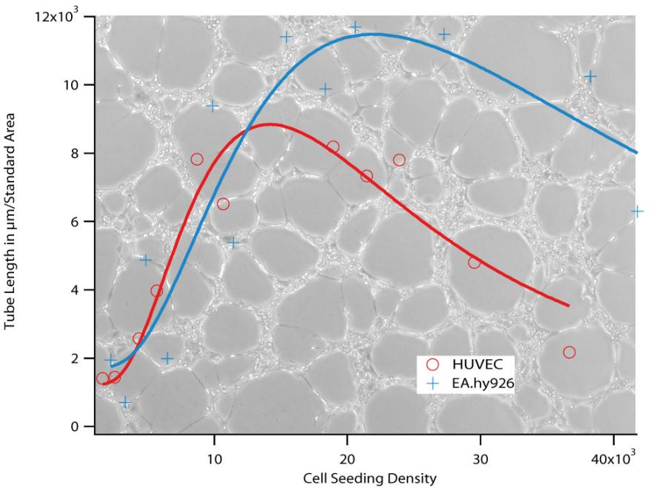
Application Note 27
Data Analysis of Tube Formation Assays
1. Introduction......................................................................................................... 2
2. Choosing the right system.................................................................................. 3
3. Data Analysis Overview ...................................................................................... 3
4. Pre!experimental work........................................................................................ 4
4.1. Optimization of Parameters.......................................................................... 4
4.2. Establishing positive and negative controls .................................................. 6
4.3. Experimental Plan and Number of Repeats.................................................. 6
4.4. Documentation............................................................................................. 6
5. Data Analysis ...................................................................................................... 6
5.1. Evaluation of pictures ................................................................................... 6
5.2. Data processing............................................................................................ 7
6. Data Interpretation .............................................................................................. 8
Application Note 27
© ibidi GmbH, Version 1.0, Helga Wagner, April 10th, 2012
Page 1 of 9

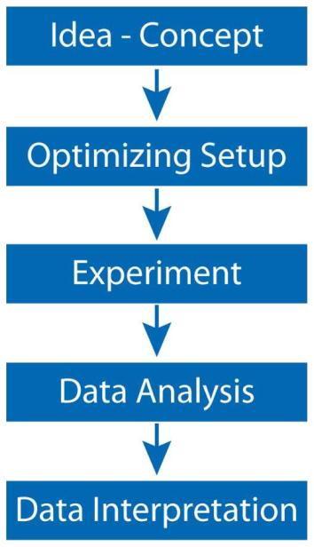

Application Note 27
1. Introduction
The tube formation assay is a powerful tool for the
screening of substances in order to discover their
anti! or pro!angiogenic effect on cultured cells. In
comparison to control cell cultures, the effect of a
substance can be measured in parameters, like such
as the length of the tubes build developing on the
gel surface or number of loops.
Performing tube formation assays requires
optimization of the practical protocol, as well as the
establishment of a data acquisition that provides
comparable data. The three critical key parameters
are the time point of data acquisition, the cell
seeding density, and the serum concentration in the
cell culture medium.
This application note will help determine the best
parameters for tube formation assays using your
own cell line, thus ensuring the acquisition of
reliable and reproducible results.
In some parts of this document, we discuss µ!Slide
Angiogenesis, but all types of tube formation
assays will show the same characteristics and
can be handled in the same way. For the specific
handling of µ!Slide Angiogenesis, please refer to
Application Note 19

NOTE: The expression „tubes“ describes the cords of cells that are visible in
a formed network. It does not mean, specifically, that the cords have a
lumen.
Application Note 27
© ibidi GmbH, Version 1.0, Helga Wagner, April 10th, 2012
Page 2 of 9

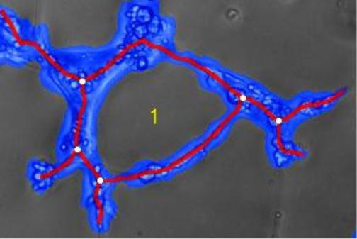
Application Note 27
2. Choosing the Right System
The first step, when starting with tube formation experiments, is to find the right
experimental system. It has to be relevant, in context to your approach, and the data
must be experimentally accessible. The three most important considerations are:
• Cell Type—tube formation is physiologically observed in endothelial cells
• Gel Matrix—it needs to be compatible with the cells and it must provide
binding motifs for cell attachment
• Medium Composition (growth factors requested?)
A setup that should work with most endothelial cells consists of Matrigel , Growth
TM
Factor!Reduced, and any endothelial cell medium with 2% serum or less.
3. Data Analysis Overview
For a better understanding of the next steps of the protocol optimization, an
overview is needed of the parameters included in the data analysis.
A microscopic picture, such as the one below, shows a tube formation network with
four detectable key parameters:
• Cell covered area (blue)
• Tubes (red)
• Loops (yellow)
• Branching points (white)
By using those values, a range of
further values can be calculated,
such as the mean tube length, the
total tube length, the mean area of
loops, and others.
There are several possible ways to analyze your pictures. One way is to do this
manually with an image manipulation software, such as ImageJ.
Another option is to use the WimTube image analysis tool, which calculates the key
parameters of the network by an automated algorithm. We recommend using this
web!based tool for maximum reproducibility and objectivity. In addition, it gives you
results within minutes. For a free trial of WimTube image analysis, please visit the
.
Application Note 27
© ibidi GmbH, Version 1.0, Helga Wagner, April 10th, 2012
Page 3 of 9

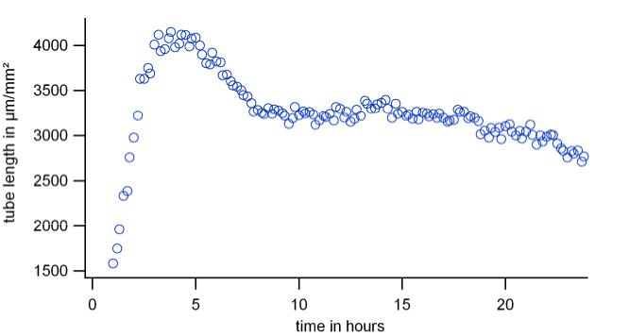
Application Note 27
4. Pre/Experimental Work
Before starting with your screening experiments, it is absolutely necessary to
optimize the experimental procedure and setup.
4.1. Optimization of Parameters
Some parameters, such as cell seeding density, time points, or serum concentration,
strongly affect the data values. Therefore, the creation of a strict protocol is crucial
for comparability of data.
4.1.1. Time Intervals for Measurement
First, choose a medium cell concentration and a tube formation!promoting setup to
record a time curve. For HUVEC ~10,000 cells per well, using Matrigel with reduced
growth factors and a medium without serum or growth factors is adequate.
Next, prepare the gel and cell suspension as described in Application Note 19, “Tube
Immediately after seeding the cells on
the gel surface, place the slide into an incubation chamber on the microscope and
start a time!lapse recording. Take a picture every 10 minutes by adjusting the focus
at each time point with a software!based tool. Alternatively, if live cell imaging isn’t
possible, then take a picture every hour, for at least the first 8 ! 10 hours, and then a
final picture after an overnight incubation period.
Finally, analyze the pictures with WimTube and visualize the curve with suitable
software. The time curve of a parameter (e.g., total tube length) typically looks like
the chart shown below. In the first hours the curve rises to a maximum, then
declines to a plateau phase (beginning at ~7 hours), and finally then slowly flattens
out (>20 hours). The characteristics of all four key parameters look similar. For this
reason, the evaluation of only one parameter is sufficient. We chose the tube length
as a parameter, because it is controlled easily by comparing the original pictures to
the evaluated ones.
The best results are found at the maximum phase and also in a stable phase that
does not decline too fast. In the example above, the 5!hour mark and 10!hour mark
would be good reference points for your measurements.
Application Note 27
© ibidi GmbH, Version 1.0, Helga Wagner, April 10th, 2012
Page 4 of 9

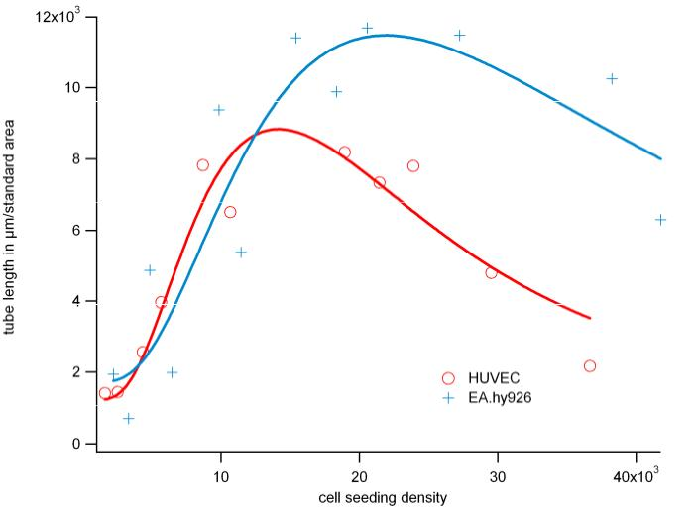
Application Note 27
4.1.2. Cell Seeding Density
For determining the optimal cell seeding density, record the characteristics of your
cell line.
First, make a dilution series in the range of 5!40 x 10 cells/ml and then seed the
3
cells onto the gel surface. Incubate the slide for the determined length of time, after
following the instructions in section 4.1.1., and then take phase contrast pictures.
Make at least five repeats per cell concentration.
Then, evaluate the images, as mentioned in Sections 3 and 5, respectively. Visualize
the data in a graph, as shown below. The data will once again show a characteristic
curve with a maximum value. This maximum marks the best seeding density for
your cell type.
4.1.3. Serum Concentration
The addition of serum to the culture medium might influence the tube formation
behavior. In most cases, the serum inhibits tube formation. To avoid this problem,
try different serum concentrations, from 0% up to 20%, with the parameters you
defined in Sections 4.1.1 and 4.1.2. This will help you decide which concentration is
best for tube formation and cell survival.
4.1.4. Magnification
The magnification determines the dimension of the representative screen section that
will be shown on the chip of the camera. Because tube formation is a process that
uses the whole surface of the well, it is important to image the widest possible
section. If you are not interested in detecting cellular details, it is recommended to
use a small magnification of 4x or 5x . When this is not possible, you can also stitch
images that have a higher magnification.
Application Note 27
© ibidi GmbH, Version 1.0, Helga Wagner, April 10th, 2012
Page 5 of 9

Application Note 27
4.2. Establishing Positive and Negative Controls
To create a positive control, choose a setup where tube formation is assured (e.g.,
Matrigel with reduced growth factors and serum!free medium for HUVEC). The
positive control will ensure that the cells are healthy and also that any anti!angiogenic
effects that are observed are being caused by the investigated substances.
To create a good negative control, choose a substance that is proven to have an
inhibiting effect on tube formation development (e.g., suramine for HUVEC). The
negative control will ensures that the cells are not inert to inhibition and will give a
comparable value to the values of your experiment.
4.3. Experimental Plan and Number of Repeats
Before starting the whole experimental series, calculate the amount of the required
material, such as cells, media, gel matrix, and substances, as well as the laboratory
requirements and the time schedule.
For a stable statistical analysis, a minimum of four independent experiments is
recommended, each with a minimum of 8 single wells. The required number of
repeats is dependent on the homogeneity of the data. Following a strict protocol is
crucial for data acquisition. The p!value of the Students!T!test will provide feedback,
if your data is homogeneous enough.
4.4. Documentation
A reasonable documentation includes all of the parameters that where determined
in this section. Generate a tabular chart in which every experiment is recorded in
one column. An example is given in the appendix.
5. Data Analysis
5.1. Evaluation of Pictures
The microscopic pictures need to be analyzed, in order to quantify the
characteristics of the network. This can be done by hand with an image processing
software, or by sending the pictures to the automated image analysis at Wimasis
GmbH.
A free trial of 10 images is available, so that you can evaluate the image analysis
performance. Please follow these steps to test your own images:
1.
Create an account at:
https://mywim.wimasis.com/index.php?page=Launch&select=Tube_Formation&gr=ibidi
Activate your account by confirming of the registration email.
2.
3.
4.
Login at: https://mywim.wimasis.com/index.php?page=Home&gr=ibidi
Upload your images after choosing the right magnification range (see
Section 4.1.4). The magnification level affects the expected values for the
cell dimensions, in terms of the given thresholds.
5.
The following graphical formats are accepted:
*.jpg, *.jp2, *.png, *.gif, *.tiff, *.tif, *.bmp
Application Note 27
© ibidi GmbH, Version 1.0, Helga Wagner, April 10th, 2012
Page 6 of 9

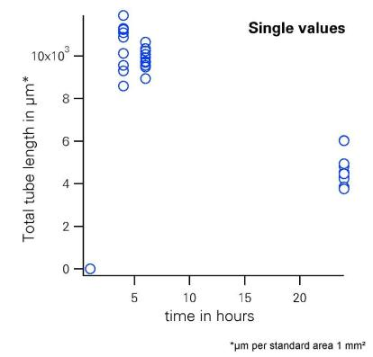
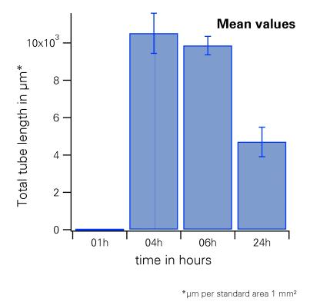

Application Note 27
6.
After a few minutes, the results will be ready to be downloaded. You will
receive the following:
• single images with colored cell area, tubes, nodes, and loops
• a summary.csv!file with all of the measured and calculated values
The key metrics are
!
!
!
!
!
Cell covered area [%]
Total tube length [px]
Total number of branching points
Total number of loops
Total number of nets (connected network of tubes)
All of the key metrics will show the same characteristic over the experimental span of
time, therefore it is sufficient to evaluate only one parameter. The most stable and
traceable value is the total tube length. Therefore, we recommend evaluating only the
tube length as a representative value for the formation of tubes (see also 4.1.1).
5.2. Data Processing
Each analyzed well generates one tube length value. The values of one experiment
(minimum 8 wells per condition) are then summed up and a standard deviation is
calculated. The standard deviation should not be more than 10%. This is just one
experimental data point.
The left graph shows the distribution of single well results for one experimental
condition, at four different time points.
Application Note 27
© ibidi GmbH, Version 1.0, Helga Wagner, April 10th, 2012
Page 7 of 9

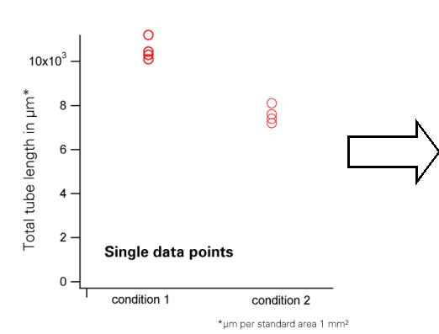
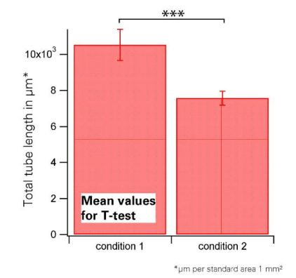
Application Note 27
For a stable statistical analysis, at least four data points for each condition are needed.
Please keep in mind that each data point consists of 8 individual wells.
The single data points are grouped into a mean value and can be displayed in a bar
plot. Statistical analysis is done by a Student’s T!test, in which the different
populations of data points are tested against each other.
6. Data Interpretation
The Student’s T!test gives evidence of whether or not the two separate samples,
with t!distributed values, differ significantly from each other. This will depend on the
number of repeats. It is recommended to perform the T!test with suitable statistical
software or in Microsoft Excel.
It is important to consider what can realistically be predicted with the tube formation
data. Tube formation is a very complex process that combines a huge variety of
biochemical reactions and pathways. In our opinion, this experimental setup is
suitable for a screening of substances, and for a preliminary prediction of whether or
not the substance influences tube formation processes. It does not explain how this
influence works. For further investigation, more profound biochemical analysis will
need to be done.
Application Note 27
© ibidi GmbH, Version 1.0, Helga Wagner, April 10th, 2012
Page 8 of 9


Application Note 27
Appendix:
Documentation Example
Date
Conducted by:
08.12.2011
HW
Experimental Parameters:
Cell type:
HUVEC
Passage:
P2
Medium:
EC Medium without supplements
Concentration Cell Suspension
Confluence before Seeding:
Gel matrix:
2x105 c/ml
70%
Matrigel with GFs
5 min
Time in Suspension (max. 15 min):
A1
A2
A3
A4
A5
B1
B2
B3
B4
B5
C1
C2
C3
C4
C5
negative control
negative control
negative control
negative control
negative control
positive control
positive control
positive control
positive control
positive control
Microscope/Imaging
Microscope:
Camera:
Image dimension in pixel:
Image dimension in mm²:
Objective:
Nikon Ti
DS!Qi1Mc
1280x2048
6.97
4x
Large Image:
1x2
Dimension of pixel (µm/px):
Number of images:
Time points:
1,61 µm/px
3
1h, 6h, 24h
Analysis
Analysis date:
Analyzed by:
Modul:
Date
Conducted by:
09.06.2011
Wimasis
wimtube low magnification
08.12.2011
HW
Application Note 27
© ibidi GmbH, Version 1.0, Helga Wagner, April 10th, 2012
Page 9 of 9

