

Application Note 23
3D Chemotaxis Protocol with Collagen I Gel for
Dendritic Cells
1. General information
This is a specialized protocol for analyzing chemotaxis of murine dendritic cells
embedded in a 3D collagen matrix. More general information is provided in the
3D
Application Note 17 “3D Chemotaxis Assays using μ-Slide Chemotaxis “.
2. Equipment needed
For this protocol the following equipment and instruments are necessary:
• Cell culture incubator (high humidity, 37 °C, 5 % CO2)
• Inverted microscope with 10x objective lens (phase contrast) and time lapse
function
• Stage top incubator (37 °C, 5 % CO2)
• Optional: Motorized stage and autofocus (x,y,z) to observe all 3 chambers in
parallel.
• Computer with ImageJ plugin “Manual Tracking” and “Chemotaxis and
Migration Tool” from ibidi.
3. Cell culture of dendritic cells
One day before experiment:
• To inhibit the development of bubbles degas your slides and media in an
incubator (37 °C) for 24 h.
• Dendritic cells (on day 8 – 10) are activated over night with 200 ng/ml LPS (in
cell culture medium as described in table 1).
Reagent/Material
Concentration
Company
Order No.
Cell culture
Dendritic cells (murine)
RPMI 1640
FCS
-
1x
Self-prep*
Invitrogen
Invitrogen
PAA
-
31870025
10270106
M11-004
P11-010
315-03
10%
L-Glutamin
5%
Penicillin/Streptomycin
GM-CSF
5%
PAA
10-20 ng/ml*
200 ng/ml
Peprotech
Sigma-Aldrich
Cell activation
LPS
L4516
Table 1. Material and reagents needed for cell culture of dendritic cells.
* as published in:
Lutz, M. B. et al. An advanced culture method for generating large quantities of highly pure dendritic
cells from mouse bone marrow. J. Immunol. Methods 223, 77–92 (1999)
Application Note 23
© ibidi GmbH, Version 1.0, Julia Riedl, July 12
th
2010
Page 1 of 6


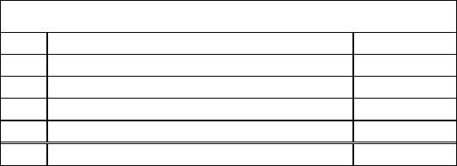
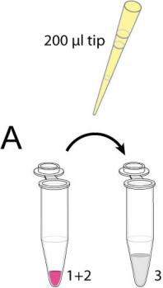
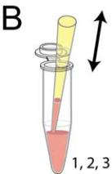
Application Note 23
4. Gel preparation, Collagen I, bovine, 1.6 mg/ml
The following reagents and material is necessary for the chemotaxis experiment
with dendritic cells:
Reagent/Material
Concentration
Company
Order No.
Cells
Dendritic cells (murine)
Collagen I, bovine
NaHCO3
9 x 10
6
c/ml
Self-prep
Nutacon
-
Gel preparation
3 mg/ml
7.5 %
10x
5005-B
S8761
Sigma-Aldrich
Sigma-Aldrich
R&D Systems
ibidi
10x MEM
M-0275
361-MI-025
80326
Chemoattractant
CCL19
1.25μg/ml
-
μ-Slide
μ-Slide Chemotaxis 3D
Table 2. Material and reagents needed for chemotaxis experiment with dendritic cells.
Vtotal = 270μl
No.
1
Component
10x MEM
Amount
20μl
2
NaHCO3
10μl
3
4
Collagen I, bovine
Cell suspension
∑
150μl
90μl
270μl
Table 3. Preparation of a 1.6 mg/ml gel
1. Prepare a cell suspension of 9 x 10 cells/ml in the
6
cell culture medium mentioned in table 1.
2. Carefully mix the components 1 and 2 in a 1.5 ml
tube avoiding air bubbles.
3. Prepare 150 μl collagen (component 3) in a 1.5 ml
tube.
4. Transfer the 30 μl mix of Nr. 2 into the collagen
tube. Use a 200 μl pipet tip for immediate mixing of
a larger volume (see A).
5. Mix well, but carefully (see B). It is important to
avoid air bubbles during mixing!
6. Add 90 μl of the cell suspension (Nr. 1) into the mix
(see C).
7. Mix well, but carefully (see D). It is important to
avoid air bubbles during mixing!
Application Note 23
© ibidi GmbH, Version 1.0, Julia Riedl, July 12
th
2010
Page 2 of 6

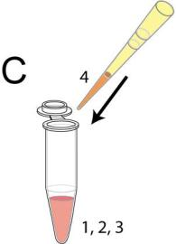
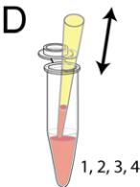
Application Note 23
8. Immediately after that fill the mix into the channels
as described in Application Note 17.
9. Place the slide into the incubator for 30 – 35 min for
gelation. After that collagen fibers become visible.
Notes:
• Let bubbles in the pipette ascend to the top of the
solution before pipetting into the slide.
• Avoid bubbles in your gel. They may destroy
collagen-fibers, influence time-lapse recordings and
optical properties of the gel. Don’t use a vortex
mixer.
• After making the collagen-mix, there are ca. 5 min
left to pipette the gel before gelation starts.
• In case of pipetting after gelation, big damages in
collagen-fibers must be expected.
• A color change will be observed (indicator turns into
pink) when 10xMEM is added to sodium
bicarbonate - this is not the final chemical
equilibrium. Thus, the mixture must be mixed
gently, while adding to collagen.
5. Chemotaxis experiment
Chemoattractant: CCL19 (1.25 μg/ml in RPMI 1640 / 10%FCS)
Chemoattractant-free medium: RPMI 1640, 10% FCS
1. After gelation of the gel, fill up the reservoirs with
either chemoattractant-free or chemoattractant-
containing medium.
2. For the chemotaxis experiment itself (+/-) fill one
reservoir with 60 μl chemoattractant-containing
medium and the other with 60 μl chemoattractant-
free medium.
3. For a control experiment (-/-) fill both reservoirs with
60 μl chemoattractant-free medium.
4. Close the slide according to Application Note 17.
The slide is now ready for video microscopy.
5. Put the slide into the stage top incubator.
6. Focus into the center of the gel and acquire images
for 4 hours with a time lapse interval of 2 min.
Application Note 23
© ibidi GmbH, Version 1.0, Julia Riedl, July 12
th
2010
Page 3 of 6

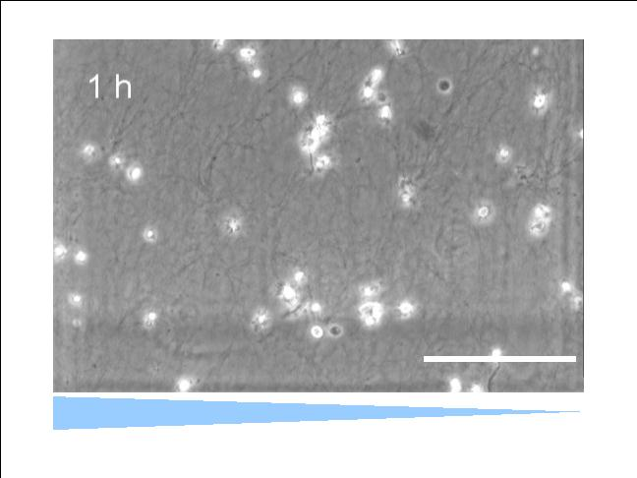
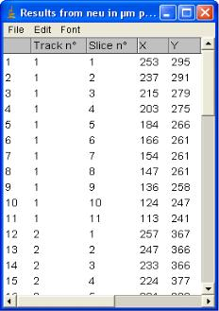
Application Note 23
Observation in the micrsocope: Because of the 3D environment, not all cells will be
perfectly in focus depending on the used objective.

200μm
CCL19 gradient
Figure 1. Bright-field image during time-lapse microscopy 1 hour after experimental set-up.
6. Manual cell tracking
1. After the experiment, track the cells with appropriate software. We suggest
e.g. Manual Tracking, an ImageJ plugin able to quantify movement of objects
between frames of a temporal stack.
2. ImageJ is available here: http://rsb.info.nih.gov/ij/
3. The Manual Tracking plug-in (including a pdf documentation) by Fabrice
Cordelières, Institut Curie, Orsay, France is available here:
http://rsbweb.nih.gov/ij/plugins/track/track.html
4. Download Manual_Tracking.class into the plugins folder of ImageJ on your
computer and restart ImageJ. Make sure you have administrator rights.
5. Quick guide for tracking with Manual Tracking:
➢ Import movie as single page .tif files by
using „File/Import/Image_Sequence”.
➢ Open plugin “Manual Tracking”.
➢ Select “Add track”.
➢ Follow the first cell over all time points by
clicking on it. After the first click the
software creates the results table in an
extra window. This table is filled with the
x/y data of each cell at each point of time.
➢ Save the data table after tracking is
complete.
Application Note 23
© ibidi GmbH, Version 1.0, Julia Riedl, July 12
th
2010
Page 4 of 6

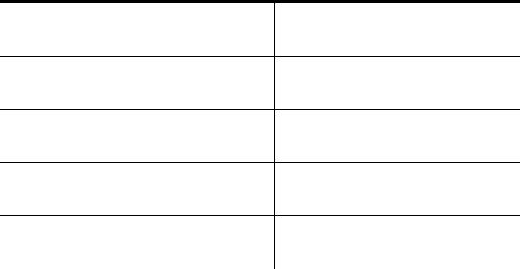
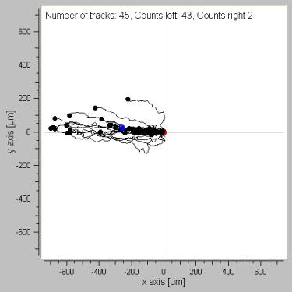
Application Note 23
6. The data table contains all tracked cells (=tracks) and time points (=slices)
with (x,y) positions.
7. Track cells uniformly in order to ensure homogeneity. Avoid tracking the
same cell twice. At least 30 cells need to be tracked for statistical reasons.
Some cells will be lost through cell death. Do not use such cells for data
analysis.
8. Optionally, export “Overlay dots & lines” as .avi.
7. Data evaluation with the Chemotaxis and Migration Tool:
The Chemotaxis and Migration plugin for ImageJ is available here:
http://www.ibidi.de/applications/ap_chemo.html
For data interpretation the Forward Migration Indices* (FMIs) of the chemotaxis
experiment and the control experiment are compared. In case of chemotaxis all FMI
components of the control experiments (-/-) and the perpendicular FMI of the
┴
chemotaxis experiment (+/-) should be around 0. Value of FMI of the chemotaxis
║
experiment (+/-) significantly different from 0 represent a chemotaxis effect.
Additionally, the p-values of the Rayleigh test** of all experiments are compared to
judge for homogeneous angular distributions of the cell endpoint with respect to
origin. p-values larger p = 0.05 indicate an homogeneous cell endpoint distribution
and, therefore, non-directed migration.
Moreover, migration parameters such as directness and velocity can be used for
analysis.
*Foxman et al. Integrating conflicting chemotactic signals. The role of memory in leukocyte
navigation, J Cell Biol147, 577-588 (1999)
**Fisher, N. I. Statistical Analysis of Circular Data, Cambridge University Press, New York (1993)
Results:
Chemotaxis experiment (+/-) (n = 40 cells)
FMI
FMI
║
-0.646586
0.0656136
0.66121
┴
Directness
Velocity (μm/min) ± SD 2.87924 ± 1.13038
p-value (Rayleigh test)
8.87631 x 10
-16
→Directed migration towards chemoattractant
Application Note 23
© ibidi GmbH, Version 1.0, Julia Riedl, July 12
th
2010
Page 5 of 6

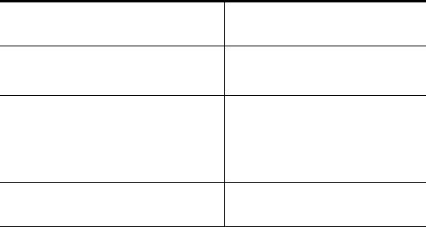
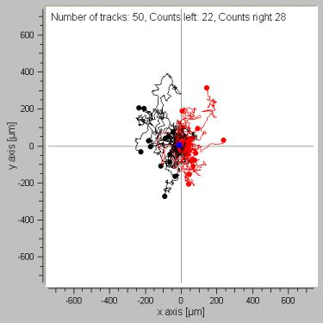
Application Note 23
Control experiment (-/-) (n = 50 cells)
FMI
║
0.00371511
0.0493364
FMI┴
Directness
0.153527
Velocity (μm/min) ± SD 2.39685 ± 0.956164
p-value (Rayleigh test)
0.680899
→ Non-directed migration
8. Notes:
• Lower magnification objectives (4 x - 10 x) provide a larger depth of focus and
are therefore advantageous.
• Automated cell tracking:
The company Wimasis is developing a solution for automated cell tracking of
phase contrast image stacks. More information on automated cell tracking is
available here www.wimasis.com.

Application Note 23
© ibidi GmbH, Version 1.0, Julia Riedl, July 12
th
2010
Page 6 of 6

