
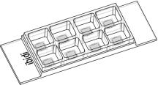

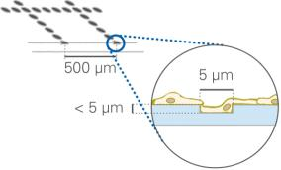
Instructions
µ–Slide8WellGrid–500
Theibidiproductfamilyiscomprisedofavarietyofµ–Slidesandµ–Dishes,whichhaveall
been designed for high–end microscopic analysis of ﬁxed or living cells. The high optical
qualityofthematerialissimilartothatofglass,soyoucanperformallkindsofﬂuorescence
experimentswithuncompromisedresolutionandchoiceofwavelength.
The µ–Slide 8 Well is an array of 8 square ﬁelds where cells can be cultivated and, subse-
quently,investigatedwithmicroscopicalmethods. Itisintendedfortheoptimizationofex-
perimentalparameterslikeantibodydilution,seedingdensity,orthemosteffectivedrugconcentration.
TheGrid–500isagridstructureforrelocatingevents. Itprovides100distinguishableobservationsquaresof500µmedge
length. ThegridisclearlyvisiblebyphasecontrastmicroscopyandbasedonthehighqualityibidiStandardBottom. The
outerdimensionsandotherparametersareidenticaltoibidiµ–Slide8Well.
Material
ShelfLifeofDifferentSurfaces
ibiTreat,GlassBottom,ESS
Collagen,Poly-Lysine
Fibronectin
36months
18months
4months
ibidiµ–Slides,µ–Dishes,andµ–Platesaremadeofaplas-
tic that has the highest optical quality. The bottom ma-
terial exhibits extremely low birefringence and autoﬂuo-
rescence, similar to that of glass. Also, it is not possible
todetachthebottomfromtheupperpart. Theµ–Slides,
µ–Dishes, and µ–Plates are not autoclavable, since they
areonlytemperature–stableupto80°C/175°F.Pleasenote
that gas exchange between the medium and incubator’s
atmosphere occurs partially through the polymer cover-
slip,whichshouldnotbecovered.
CharacteristicsoftheGrid
OpticalPropertiesibidiStandardBottom
TheGrid–500ismadeofsmalldotsinsidetheibidiplastic
surfaceofibidiµ–Slide8Wells.Thestructureisimprinted
onthesideonwhichcellsaregrowinganddoesnoteffect
cellgrowth,coatingprotocols,orsurfaceproperties. Pro-
liferation and cell behavior is comparable with standard
non–griddedslides. Cellsandgridareinonefocalplane.
Pleasealsorefertotheinstructionsofibidiµ–Slidesforin-
formationonsurfaces,coatings,andcellseeding.
RefractiveindexnD(589nm)
Abbenumber
1.52
56
Thickness
No.1.5(180µm)
Material
microscopyplastic/
polymercoverslip
Please note! The ibidi Standard Bottom is compatible
withcertaintypesofimmersionoilonly. Alistofsuit-
ableoilscanbefoundonpage3.
Thegridismadeofdotsforminggrooves,whichare5µm
(±1µm) wide and approximately 5µm deep. Cells can
grow in the grooves as well. We recommend using ob-
jectivelensesupto20×.Anyhow,theopticalqualitymeets
the requirements of 63× and 100× oil objective lenses as
well(ibidiStandardBottom,No.1.5).
ShippingandStorage
The µ–Slides, µ–Dishes and µ–Plates are sterilized and
weldedinagas-permeablepackaging.Theshelflifeunder
proper storage conditions (in a dry place, no direct sun-
light)islistedinthefollowingtable.
Conditions
Shippingconditions
Storageconditions
Ambient
RT(15-25°C)
µ–Slide8WellGrid–500
Page1
Version2015-08-06

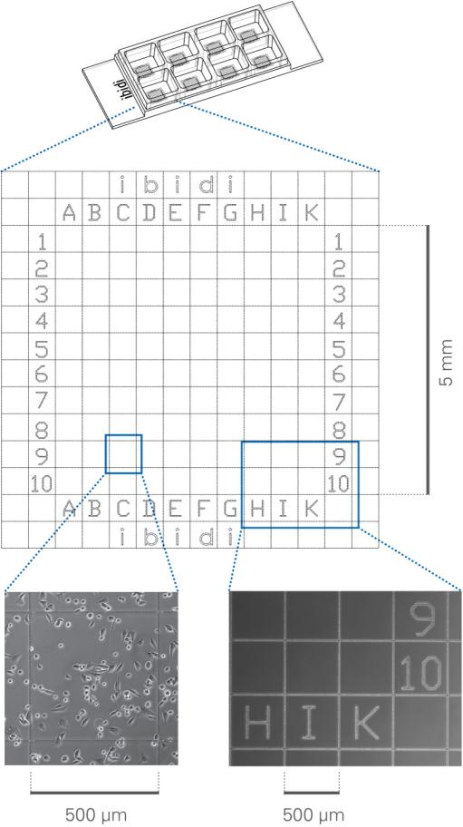
Instructions
µ–Slide8WellGrid–500
GeometryoftheGrid–500
SurfaceandCoating
Theµ–Slide8WellGrid–500isavailablewithibiTreatand
uncoatedsurface. TheibiTreatsurfaceisaphysicaltreat-
mentandoptimizedforadhesionofmostcelltypes.Many
celllinesaswellasprimarycellsweretestedforgoodcell
growth. Theuncoatedsurfaceisaveryhydrophobicsur-
faceandallowsnodirectcellgrowth.Itissuitableforspe-
ciﬁccoatingsorsuspensioncells.
GeometryoftheGrid–500
Numberofviewﬁelds
100
Repeatdistance
Groovewidth
Groovedepth
500µm
5µm(±1µm)
< 5µm
If you like to establish a particular coating for your de-
mandswerecommendtotestyourcoatingprocedureon
uncoatedandibiTreatµ–Slides, sincesomebiomolecules
adhere differently to hydrophobic or hydrophilic plastic
surfaces.
Thesquaresarecentredinthewellsandindicatedbylet-
tersandnumbersrangingfromAtoK(Jnotused)and1
to10.
• Prepareyourcoatingsolutionaccordingtotheman-
ufacturer’sspeciﬁcationsorreference. Prepareyour
µ–Slide,ibiTreatoruncoated. Adjusttheconcentra-
tiontoacoatingareaof2.2cm2and300µl.
• Apply300µlintothegrowtharea. Makesurethat
theentirebottomiscoveredwithliquideasilytilting
orshakingtheµ–Slide. Putonthelidandleaveat
roomtemperatureforatleast30minutes.
• Aspiratethesolutionandwash. Optionally,letdry
atroomtemperature.
DetailedinformationaboutcoatingsisprovidedinAppli-
cationNote08
Seedingcells
• Trypsinizeandcountcellsasusual. Dilutethecell
suspensiontothedesiredconcentration.Depending
onyourcelltype,applicationofa5-11×104cells/ml
suspensionshouldresultinaconﬂuentlayerwithin
2–3days.
• Apply300µlcellsuspensionintoeachwelloftheµ–
Slide.Avoidshakingasthiswillresultininhomoge-
neousdistributionofthecells.
• Cover the slide with the supplied lid. Incubate at
37°Cand5%CO2asusual.
Undemanding cells can be left in their seeding medium
foruptothreedaysandgrowtoconﬂuencethere. How-
ever, best results might be achieved when the medium
is changed every 1–2 days. Carefully aspirate the old
mediumandreplaceitby300µl/wellfreshmedium.
µ–Slide8WellGrid–500
Page2
Version2015-08-06


Instructions
µ–Slide8WellGrid–500
avarietyofchemicals,e.g.,acetoneormethanol. Further
speciﬁcationscanbefoundatDuetothe
thinbottomofonly180µm,highresolutionmicroscopyis
possible.
Tip:
Asyoumayknowfrom96wellplates,thebentmenis-
cus at the air–liquid interphase in small open wells
destroysthephasecontrasteffectofyourmicroscope
image. Toavoidthisproblem,werecommendusing
ImmersionOil
ourchannelSlidessuchastheµ–SlidesILuerandµ–
SlideVI0.4oraPh+Slide.
When using oil immersion objectives, use only the im-
mersion oils speciﬁed in the table. The use of a non–
recommendedoilcouldleadtothedamageoftheplastic
materialandtheobjective.
PreparationforCellMicroscopy
Company
Product
OrderingNumber
To analyze your cells, no special preparations are neces-
sary.Cellscanbeobservedlive,orﬁxeddirectlyintheµ–
Slideonaninvertedmicroscope. Youcanuseanyﬁxative
of your choice. The µ–Slide material is compatible with
Zeiss
Zeiss
Leica
Immersol518F
ImmersolW2010
Immersionliquid
(Zeiss)444960
(Zeiss)444969
(Leica)11513859
µ–Slide8WellGrid–500
Page3
Version2015-08-06

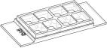
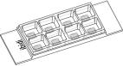
Instructions
µ–Slide8WellGrid–500
OrderingInformation
Theµ–Slide8WellfamilycomprisesSlideswithdifferentsurfacesandbottomcharacteristics.Seetablebelowforchoosing
yourµ–Slide8Well.
µ–Slide8Well
Cat.No.
Description
80826
80822
80823
80824
80825
80821
µ–Slide8WellibiTreat:#1.5polymercoverslip,tissueculturetreated,sterilized
µ–Slide8WellCollagenIV:#1.5polymercoverslip,sterilized
µ–Slide8WellFibronectin:#1.5polymercoverslip,sterilized∗
µ–Slide8WellPoly-L-Lysine:#1.5polymercoverslip,sterilized
µ–Slide8WellPoly-D-Lysine:#1.5polymercoverslip,sterilized∗
µ–Slide8WellUncoated:#1.5polymercoverslip,hydrophobic,sterilized
∗availableonrequestonly
µ–Slide8WellGlassBottom
Cat.No.
Description
80827
µ–Slide8WellGlassBottom:1.5H(170µm±5µm)D263MSchottglass,sterilized
µ–Slide8WellGrid–500
Cat.No.
Description
80826-G500
µ–Slide 8 Well ibiTreat Grid–500: #1.5 polymer coverslip, tissue culture treated,
gridrepeatdistance500µm,sterilized
80821-G500
µ–Slide8WellUncoatedGrid–500: #1.5polymercoverslip,hydrophobic,gridre-
peatdistance500µm,sterilized
Forresearchuseonly!
FurthertechnicalspeciﬁcationscanbefoundatForquestionsandsuggestionspleasecontactusbye-mailinfo@ibidi.de
orbytelephone+49(0)89/52046170.AllproductsaredevelopedandproducedinGermany.
©ibidiGmbH,AmKlopferspitz19,82152Martinsried,Germany.
µ–Slide8WellGrid–500
Page4
Version2015-08-06

