
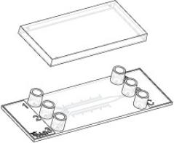

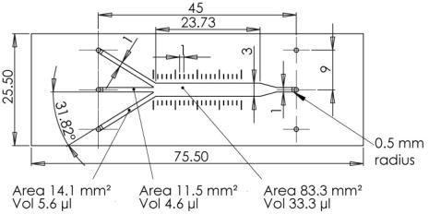
Instructions
µ–SlideIII 3in1
Theibidiproductfamilyiscomprisedofavarietyofµ–Slidesandµ–Dishes,whichhaveall
beendesignedforhigh–endmicroscopicanalysisofﬁxedorlivingcells. Thehighoptical
qualityofthematerialissimilartothatofglass,soyoucanperformallkindsofﬂuorescence
experimentswithuncompromisedresolutionandchoiceofwavelength.
Theµ–SlideIII3in1isdesignedforﬂowassayswithdifferentliquidsmergingintoonechan-
nel. Itcanbeconnectedtoapumpandenablesyoutoobservecellsunderswitchableﬂow
conditions. The design allows generating ﬂuid stable concentration proﬁles in the main
channel for e.g. chemotaxis experiments. The microﬂuidic system can generate spatially
andtemporallycontrolledgradientsofchemotacicfactorsbylaminarﬂow.
Material
pensabletotreattheuncoatedµ–Slidewithbiopolymers,
whichmediatecelladhesionandgrowth.
ibidiµ–Slides,µ–Dishes,andµ–Platesaremadeofaplas-
tic that has the highest optical quality. The bottom ma-
terial exhibits extremely low birefringence and autoﬂuo-
rescence, similar to that of glass. Also, it is not possible
todetachthebottomfromtheupperpart. Theµ–Slides,
µ–Dishes, and µ–Plates are not autoclavable, since they
areonlytemperature–stableupto80°C/175°F.Pleasenote
that gas exchange between the medium and incubator’s
atmosphere occurs partially through the plastic bottom,
whichshouldnotbecovered.
Geometry
Theµ–SlideIII3in1providesstandardslideformataccord-
ingtoISO8037/1.
Geometryoftheµ–SlideIII3in1
Adapters
femaleLuer
60µl
Volumeperreservoir
Numberofchannels
Totalchannelvolume
Heightofallchannels
Widthofchannelsthin/thick
Totalgrowtharea
OpticalPropertiesibidiStandardBottom
3in1
60µl
RefractiveindexnD(589nm)
Abbenumber
1.52
0.4mm
56
1/3mm
1.23cm2
Thickness
No.1.5(180µm)
microscopyplastic
Material
Distanceofscalebars
Bottommatchescoverslip
1mm
No.1.5
Please note! The ibidi standard bottom is compatible
withcertaintypesofimmersionoilonly. Alistofsuit-
ableoilscanbefoundonpage4.
µ–SlideSurfaces
Dependingonthetypeofcellsandthespecialapplication
youareusing,youwillneedµ–Slideswithdifferentsur-
faces.Ifyoudonotrequireanyspecialadhesionmolecules
foryourapplication,thebestchoicewillbeibiTreat,atis-
sueculturetreatedsurface.
Coatingyourµ–SlideIII 3in1
Weprovideprecoatedµ–Slideswithadhesionsubstrates
likeCollagenIV,Fibronectin,Poly–L–Lysin,andPoly–D–
Lysin.Suchadhesionsubstrateshavebeenshowntostim-
ulatetheadhesionandgrowthofvariouscelllinesinµ–
Slides.Onlyhigh–qualitysubstratesareused1.
Theuncoatedµ–Slidemustbecoatedtopromotecellad-
hesion.Ifyouwanttoestablishacertaincoatingtomatch
your needs, we recommend testing your coating proce-
dure on both uncoated and ibiTreat µ–Slides, since we
haveobservedthatsomebiomoleculesadheredifferently
tohydrophobicandhydrophilicplasticsurfaces.
Theuncoatedµ–Slideismanufacturedfromhydrophobic
plastic. For the cultivation of most cell lines, it is indis-
1CollagenIV:Corning#356233,Fibronectin:Corning#354008,Poly–L–Lysin:Sigma#P4832,Poly–D–Lysin:Corning#354210
µ–SlideIII3in1
Page1
Version2014-05-13

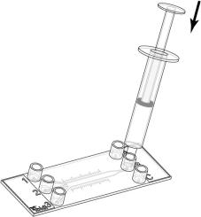

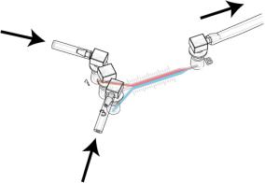
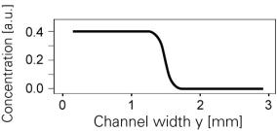
Instructions
µ–SlideIII 3in1
• Prepareyourcoatingsolutionaccordingtotheman-
ufacturer’sspeciﬁcationsorreference.
• Apply60µlcellsuspensionintoadapterBoftheµ–
Slide. Quickdispensinghelpstoavoidtrappedair
bubbles.
• Apply60µltoadapterB(handlingseebelow)and
leaveatroomtemperatureforatleast30minutes.
• Coverreservoirswiththesuppliedlid. Incubateat
37°Cand5%CO2asusual.
• Aspiratethesolutionandwashwithultra–purewa-
ter.Youcanaddthewaterintoonechannelendand
simultaneously aspirate it on the other side. Take
carethatallofthethreechannelsarewashed.
• Await cell attachment in order not to ﬂush out the
cells. Afterwards ﬁll each reservoir with 60 µl cell
freemedium.
• Optionallyletdryatroomtemperature. Attention,
somecoatingproteinsmightdegeneratewhendry-
ing!
• Connecttheµ–Slidetothepumpandconductyour
perfusionexperiment.
Furtherinformationaboutcoatingsareprovidedin

Important!
Thedaybeforeseedingthecellswerecommendplac-
ingthecellmediumandtheµ–Slideintotheincubator
forequilibration. Thiswillpreventtheliquidinside
thechannelfromemergingairbubblesovertheincu-
bationtime.
FillingandHandling
• AlwaysﬁllthechannelfromadapterBasshownin
thepicture.
• Whenusingapipetmakesureyouplacethetipdi-
rectlyontothesmallchannelsinlet.
ExchangingMedium
• Especiallytheuncoated,hydrophobicchannelcanbe
ﬁlledmucheasierbyusingasmallvolumesyringe
withaLuertip.
Aspirateallfourreservoirsandﬁll60µloffreshmedium
intoreservoirB,whichwillreplacethechannelvolumeby
gravityﬂow. Repeatthisstepthreetimesuntileachreser-
voirisﬁlledwith60µl.
• Makesurethatalladaptersarecompletelyﬁlledbe-
foreLuerconnectorsarepluggedin. Otherwiseair
bubbleswillbetrapped.
FluidConnectionsandGradientShapes
2in1
SeedingCells
• Trypsinizeandcountcellsasusual. Dilutethecell
suspensiontothedesiredconcentration.Depending
onyourcelltype,applicationofa3–7×105cells/ml
resultsina20%opticalconﬂuentcelllayerafterat-
tachment.
• A seeding density of 1–4 × 106 cells/ml creates a
100% optical conﬂuent cell layer after cell attach-
ment.
Cliff-shapedGradients
Version2014-05-13
µ–SlideIII3in1
Page2

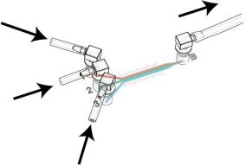
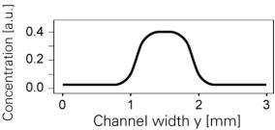
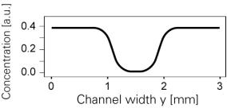
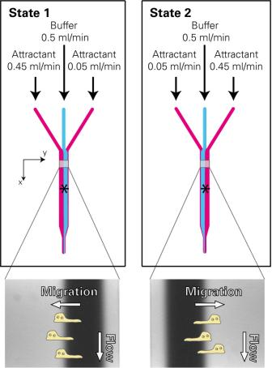
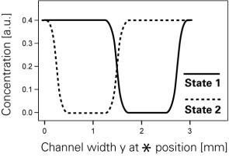
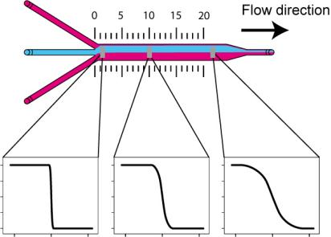
Instructions
µ–SlideIII 3in1
3in1
Concentrationproﬁlescanbevisualizedbyusingaﬂuo-
rescentdyee.g.rhodamine.Switchingtimebetweenstate
1andstate2canrangefromsecondstohours,depending
onthespeedofthecells’response.
The concentration proﬁle created is always sigmoid
shapedandisdependingonoverallﬂowrateandposition
insidethechannel.
Hill-shapedGradients
Allﬂowratesshouldbeadjustedinawaythatthepoint
ofinﬂectionofthesigmoidisatidenticalpositioninstate
1andstate2.
Cup-shapedGradients
Example Experiment – Cells in Temporally
ControlledGradients
The following example experiment illustrates the idea
howtosetupaswitchablechemicalgradientinthelarge
channelforachemotaxisexperiment.
The longer liquids are in contact next to each other the
smootherthesigmoidshapebecomes.
Sinceﬂowisusedtokeepthegradientsstable,thereisal-
ways a shear stress applied to the cells. Please perform
controlexperimentswiththeexperimentalﬂowratetoex-
cludepolarizationeffectsfromtheﬂowitself. Flowrates
andcorrespondingshearstresscanbefoundinApplica-
tionNote11onwww.ibidi.com. Forexample,aﬂowrate
of1ml/minresultsinashearstressof2.3dyn/cm2.
µ–SlideIII3in1
Page3
Version2014-05-13

Instructions
µ–SlideIII 3in1
ImmersionOil
PreparationforCellMicroscopy
When using oil immersion objectives, use only the im-
mersion oils speciﬁed in the table. The use of a non–
recommendedoilcouldleadtothedamageoftheplastic
materialandtheobjective.
To analyze your cells, no special preparations are neces-
sary.Cellscanbeobservedlive,orﬁxeddirectlyintheµ–
Slideonaninvertedmicroscope. Youcanuseanyﬁxative
ofyourchoice. Theµ–Slidematerialiscompatiblewitha
varietyofchemicals(e.g.,AcetoneorMethanol). Further
speciﬁcationscanbefoundatDuetothe
thinbottomofonly180µm,highresolutionmicroscopyis
possible.
Company
Product
OrderingNumber
ibidi
Zeiss
Zeiss
Leica
ImmersionOil
(ibidi)50101
Immersol518F
ImmersolW2010
Immersionliquid
(Zeiss)444960
(Zeiss)444969
(Leica)11513859
µ–SlideIII3in1
Page4
Version2014-05-13

Instructions
µ–SlideIII 3in1
SelectedReferences
X.Cheng,M.Joseph,J.A.Covington,T.Dafforn,M.R.Hicks,andA.Rodger. Continuouschannelﬂowlineardichroism.
RoyalSocietyofChemistry,2012.doi:10.1039/C2AY25513H.
B.Meier,A.Zielinski,C.Weber,D.Arcizet,S.Youssef,T.Franosch,J.O.R¨adler,andD.Heinrich.Chemotacticcelltrapping
incontrolledalternatinggradientﬁelds.PNAS,2011.doi:10.1073/pnas.1014853108.
F.Moseley, J.Halamek, F.Kramer, A.Poghossian, M.Schoening, andE.Katz. Enzyme-basedreversiblecnotlogicgate
realizedinaﬂowsystem.RoyalSocietyofChemistry,2014.doi:10.1039/C4AN00133H.
µ–SlideIII3in1
Page5
Version2014-05-13

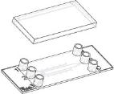
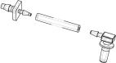
Instructions
µ–SlideIII 3in1
µ–SlideIII 3in1
Family
Theµ–SlideIII3in1familyisavailablewithdifferentsurfaces.Seetablebelowforchoosingyourµ–SlideIII3in1.
OrderingNumber TreatmentorCoating
Characteristics
80316
80312
80313
80314
80315
80311
ibiTreat,sterile
hydrophilic,tissueculturetreated
proteincoating
CollagenIV,sterile
Fibronectin,sterile∗
Poly-L-Lysine,sterile
Poly-D-Lysine,sterile∗
proteincoating
biopolymercoating
biopolymercoating
hydrophobic
uncoated,sterile
∗availableonrequestonly
TubeAdapterSet
Fortheconnectionoftheibidiµ–SlidestoanyﬂowsystemsuitableTubeAdapterSetsarealsoavailable.Theyconsistofa
tubing(20cm)withinnerdiameterof1.6mmandadaptersfortheconnectionbetweentheibidiµ–Slide(femaleLuer)and
thetubingofthepumpinuse.
OrderingNumber ProductName
Characteristics
12pcs,sterile
10831
TubeAdapterSet
Forresearchuseonly!
FurthertechnicalspeciﬁcationscanbefoundatForquestionsandsuggestionspleasecontactusbye-mailinfo@ibidi.de
orbytelephone+49(0)89/52046170.AllproductsaredevelopedandproducedinGermany.
©ibidiGmbH,AmKlopferspitz19,82152Martinsried,Germany.
µ–SlideIII3in1
Page6
Version2014-05-13

