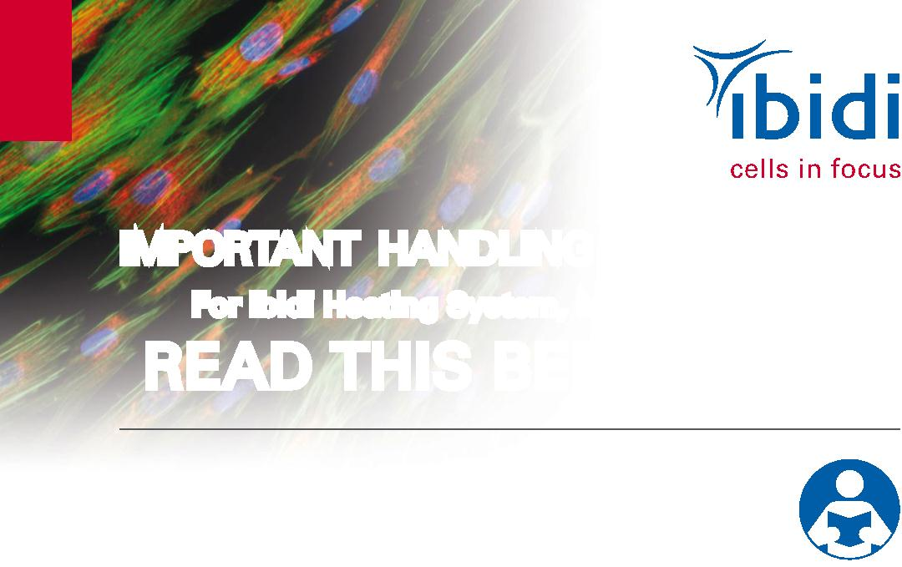

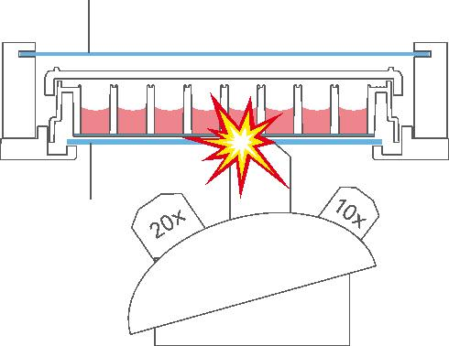
IMPORTANT HANDLING INFORMATION
For ibidi Heating System, Multi-Well Plates
READ THIS BEFORE USE
Read this information sheet, in its entirety, BEFORE working
with the ibidi Heating System for Multi-Well Plates.
The manual should also be read before using the instrument.
Heated Glass (Lid)
60x
Heated Glass Bottom
CAUTION
The glass bottom of the heated plate may break due to a mechanical impact. Avoid
contact between the glass bottom and the objective lens. Changing objective lenses
may automatically lead to a collision between the objective lens and the glass bottom.
Note: Never use an objective lens with a working distance smaller than 1 mm.
CAUTION
If the glass plate of the heated lid or the plate itself breaks due to a mechanical
impact, the shards can lead to injuries, if handled.
ibidi GmbH
Tel.:
Fax:
E-Mail: info@ibidi.de
+49 89 / 520 46 17 - 0
+49 89 / 520 46 17 - 59
For more information on our
products, and to download our
full catalog, please visit us at:
www.ibidi.com
Am Klopferspitz 19
82152 Planegg/Martinsried
Germany
© ibidi GmbH, V 1.0, 2015 / 02

